# 

# REPORT on Computer Networks (V23CSL09)

# B. TECH V Semester (2023 - 2027 Batch)

*Academic Year: 2025-26*



# SRI VASAVI ENGINEERING COLLEGE (Autonomous)

## Pedatadepalli, Tadepalligudem - 534101

## Department of Computer Science & Engineering (Accredited by NBA)

**SRI VASAVI ENGINEERING COLLEGE (Autonomous)**

**PEDATADEPALLI, TADEPALLIGUDEM.**



**Certificate**

This is to certify that this is a bona fide record of Practical Work done in **Computer Networks** Lab by Mr./Miss **Pamarthi Leela Venkata Siva Nageswararao** bearing Roll No. **24A85A0506** of **CSE** branch of **V** Semester during the academic year **2025-26**.

**No. of Experiments Done:**

**Faculty In charge: Head of The Department:**

**Examiner 1: Examiner 2:**

# INDEX

|  |  |  |  |  |
| --- | --- | --- | --- | --- |
| **Experiment No.** | **Date** | **Name of the Experiment** | **Page** | **Signature of the Faculty** |
| 1 | 08/07/2025 | Study of Network devices in detail and connect the computers in Local Area Network. | 1-3 |  |
| 2 | 08/07/2025 | Develop a Program to implement the data link layer framing methods such as  i) Character stuffing  ii) bit stuffing | 4-7 |  |
| 3 | 15/07/2025 | Develop a Program to implement data link layer farming method checksum. | 8-9 |  |
| 4 | 22/07/2025 | Develop a program for Hamming Code generation for error detection and correction. | 10-12 |  |
| 5 | 29/07/2025 | Develop a Program to implement on a data set of characters the three CRC polynomials – CRC 12, CRC 16 and CRC CCIP. | 13-15 |  |
| 6 | 29/07/2025 | Develop a Program to implement Sliding window protocol for Goback N. | 16-18 |  |
| 7 | 05/08/2025 | Develop a Program to implement Sliding window protocol for Selective repeat. | 19-21 |  |
| 8 | 05/08/2025 | Develop a Program to implement Stop and Wait Protocol. | 22-23 |  |
| 9 | 14/10/2025 | Develop a program for congestion control using leaky bucket algorithm | 24-25 |  |
| 10 | 23/09/2025 | Develop a Program to implement Dijkstra‗s algorithm to compute the Shortest path through a graph. | 26-28 |  |
| 11 | 07/10/2025 | Develop a Program to implement Distance vector routing algorithm by obtaining routing table at each node (Take an example subnet graph with weights indicating delay between nodes). | 29-31 |  |
| 12 | 09/09/2025 | Wireshark  i. Packet Capture Using Wire shark  ii. Starting Wire shark  iii. Viewing Captured Traffic  iv. Analysis and Statistics & Filters. | 32-36 |  |
| 13 | 09/09/2025 | Discover active hosts, open ports and running services in a network using Nmap | 37-38 |  |
| 14 | 09/09/2025 | Find Operating System in a host using Nmap | 39 |  |

## 1. Study of Network devices in detail and connect the computers in Local Area Network.

**Description :-**

Network devices are physical devices that allow hardware on a computer network to communicate and interact with one another. Examples include repeater, hub, bridge, switch, router, gateway, and NIC (Network Interface Card).

### Router :-

* A **router** is a networking device that forwards data packets between computer networks.
* It can connect one or more packet-switched networks or subnetworks.
* The router sends data packets to their intended IP addresses.
* It manages traffic between different networks.
* It also permits secure communication between networks.

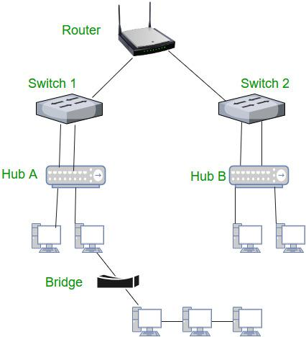

### HUB :-

* A **hub** is a simple networking device that connects multiple devices in a network.
* It acts as a **central point** for data transmission.
* When data is received on one port, the hub **broadcasts it to all other ports**.

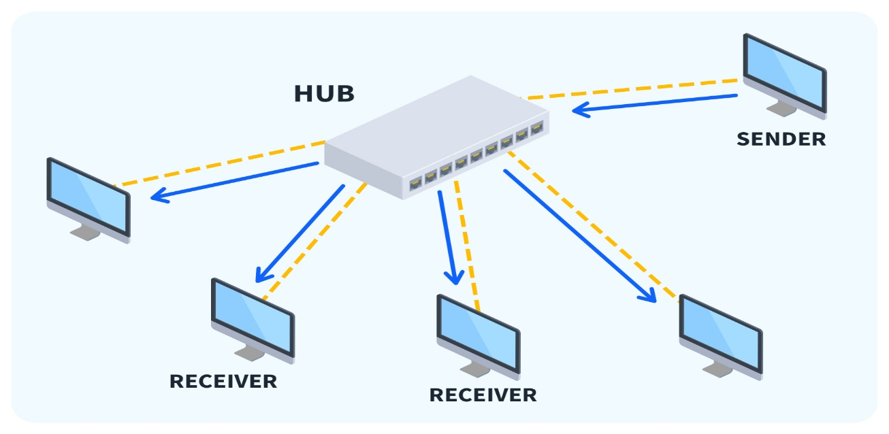

### Switch :-

* A **network switch** is a crucial piece of networking hardware that connects wired devices within a network.
* It uses **packet switching** to receive, analyze, and forward data to the correct destination.
* This ensures **efficient communication** between devices.
* Essentially, a switch acts as a **traffic controller**, directing data to where it needs to go within a local network.

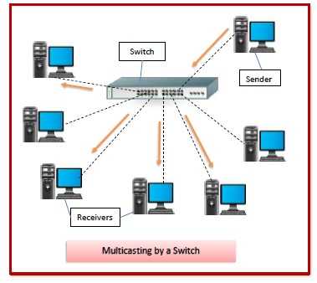

### Difference between hub and switch :-

A **hub** and a **switch** are both networking devices used to connect multiple devices within a network, but they differ significantly in how they manage data. A hub is a basic device that simply broadcasts the data it receives to all connected devices, regardless of the intended recipient. This can lead to unnecessary network traffic, collisions, and slower performance. In contrast, a switch is more advanced and efficient. It uses the **MAC (Media Access Control) addresses** of devices to identify the correct destination and forwards data only to the intended device. This targeted communication reduces congestion, improves security, and ensures faster and more reliable data transfer. Because of this, switches are considered much more efficient and secure compared to hubs.

## 2. Develop a Program to implement the data link layer framing methods such as

## i) Character stuffing

## ii) bit stuffing.

### i) Character stuffing :-

#### public class CharacterStuffing {

#### public static void main(String[] *args*) {

#### String input = "DEFGAEEFEFH";

#### String stuffed = stuffData(input);

#### String unstuffed = unstuffData(stuffed);

#### System.out.println("Stuffed: " + stuffed);

#### System.out.println("Unstuffed: " + unstuffed);

#### }

#### private static String stuffData(String *s*) {

#### StringBuilder result = new StringBuilder();

#### result.append('F');

#### for (int i = 0; i < *s*.length(); i++) {

#### char ch = *s*.charAt(i);

#### if (ch == 'E' || ch == 'F')

#### result.append('F');

#### result.append(ch);

#### }

#### result.append('F');

#### return result.toString();

#### }

#### private static String unstuffData(String *s*) {

#### StringBuilder result = new StringBuilder();

#### for (int i = 1; i < *s*.length() - 1; i++) {

#### char ch = *s*.charAt(i);

#### if (ch == 'F') {

#### if (i + 1 < *s*.length() - 1) {

#### i++;

#### result.append(*s*.charAt(i));

#### }

#### } else {

#### result.append(ch);

#### }

#### }

#### return result.toString();

#### }

#### }

### Output:-

### 

### ii) bit stuffing :-

#### public class BitStuffing {

#### public static void main(String[] *args*) {

#### String s = "01110111011111011111";

#### Stuff s1 = new Stuff();

#### s1.bitStuff(s);

#### Unstuff s2 = new Unstuff();

#### s2.bitUnstuff("011101110111110111110");

#### }

#### }

#### class Stuff {

#### String bitStuff(String *s*) {

#### int c = 0;

#### StringBuilder res = new StringBuilder();

#### for (int i = 0; i < *s*.length(); i++) {

#### res.append(*s*.charAt(i));

#### if (*s*.charAt(i) == '1') {

#### c++;

#### if (c == 5) {

#### res.append("0");

#### c = 0;

#### }

#### } else {

#### c = 0;

#### }

#### }

#### String result = res.toString();

#### System.out.println("Stuffed: " + result);

#### return result;

#### }

#### }

#### class Unstuff {

#### String bitUnstuff(String *s*) {

#### int c = 0;

#### StringBuilder res = new StringBuilder();

#### for (int i = 0; i < *s*.length(); i++) {

#### char ch = *s*.charAt(i);

#### res.append(ch);

#### if (ch == '1') {

#### c++;

#### if (c == 5 && i + 1 < *s*.length() && *s*.charAt(i + 1) == '0') {

#### i++;

#### c = 0;

#### }

#### } else {

#### c = 0;

#### }

#### }

#### String result = res.toString();

#### System.out.println("Unstuffed: " + result);

#### return result;

#### }

#### }

### Output:-



## 3. Develop a Program to implement data link layer farming method checksum.

#### import java.util.**\***;

#### public class Checksum {

#### public static void main(String[] *args*) {

#### Scanner sc = new Scanner(System.in);

#### System.out.print("Enter the length of the boolean string: ");

#### int n = sc.nextInt();

#### System.out.print("Enter boolean string: ");

#### String data = sc.next();

#### System.out.print("Enter size of blocks to divide: ");

#### int blockSize = sc.nextInt();

#### if (n % blockSize != 0) {

#### System.out.println("Error: String length must be divisible by block size");

#### return;

#### }

#### if (data.length() != n) {

#### System.out.println("Error: Actual string length doesn't match specified length");

#### return;

#### }

#### 

#### System.out.println("Divided blocks (sender): ");

#### int numBlocks = n / blockSize;

#### String[] blocks = new String[numBlocks];

#### for (int i = 0; i < numBlocks; i++) {

#### blocks[i] = data.substring(i * blockSize, (i + 1) * blockSize);

#### System.out.println(blocks[i]);

#### }

#### String sum = blocks[0];

#### for (int i = 1; i < numBlocks; i++) {

#### sum = addBinary(sum, blocks[i]);

#### System.out.println("Sum after adding block " + (i + 1) + ": " + sum);

#### }

#### String checksum = onesComplement(sum);

#### System.out.println("Checksum: " + checksum);

#### String finalSum = addBinary(sum, checksum);

#### System.out.println("Receiver final sum: " + finalSum);

#### if (allOnes(finalSum)) {

#### System.out.println("Message received (No error)");

#### } else {

#### System.out.println("Message received (Error detected)");

#### }

#### 

#### sc.close();

#### }

#### private static String addBinary(String *a*, String *b*) {

#### int n = Math.max(*a*.length(), *b*.length());

#### while (*a*.length() < n) *a* = "0" + *a*;

#### while (*b*.length() < n) *b* = "0" + *b*;

#### int carry = 0;

#### StringBuilder result = new StringBuilder();

#### for (int i = n - 1; i >= 0; i--) {

#### int bit1 = *a*.charAt(i) - '0';

#### int bit2 = *b*.charAt(i) - '0';

#### int sum = bit1 + bit2 + carry;

#### result.insert(0, sum % 2);

#### carry = sum / 2;

#### }

#### if (carry > 0) {

#### return addBinary(result.toString(), "1");

#### }

#### 

#### return result.toString();

#### }

#### private static String onesComplement(String *s*) {

#### StringBuilder sb = new StringBuilder();

#### for (char c : *s*.toCharArray()) {

#### sb.append(c == '0' ? '1' : '0');

#### }

#### return sb.toString();

#### }

#### private static boolean allOnes(String *s*) {

#### for (char c : *s*.toCharArray()) {

#### if (c != '1') return false;

#### }

#### return true; }}

### Output :-

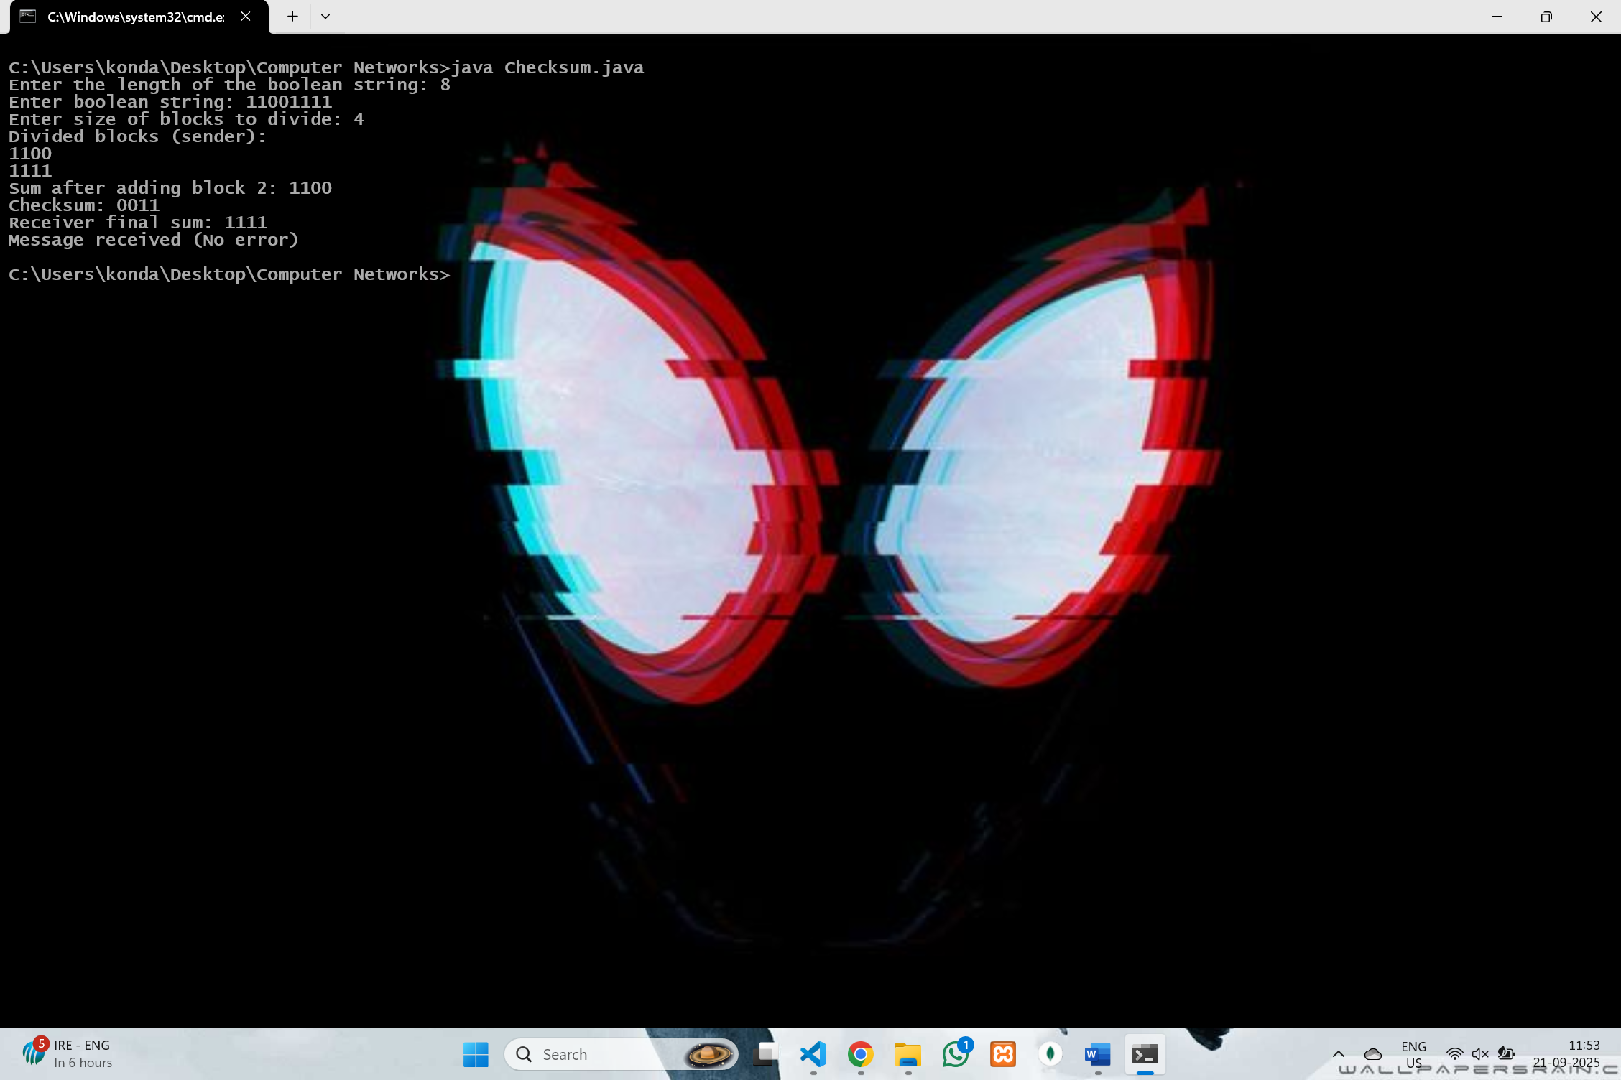

## 4. Develop a program for Hamming Code generation for error detection and correction.

import java.util.**\***;

public class HammingCode {

    public static void main(String[] *args*) {

        Scanner sc = new Scanner(System.in);

System.out.println("Sender Side :");

        System.out.print("Enter no of data bits : ");

        int m = sc.nextInt();

        int[] data = new int[m];

        System.out.println("Enter data Bits : ");

        for (int i = 0; i < m; i++) {

            data[i] = sc.nextInt();

        }

        int r = 0;

        while (Math.pow(2, r) < m + r + 1) {

            r++;

        }

        int[] hamming = new int[m + r + 1];

        int dataIndex = 0;

        for (int i = 1; i < hamming.length; i++) {

            if (isPowerOfTwo(i)) {

                hamming[i] = 0;

            } else {

                hamming[i] = data[dataIndex];

                dataIndex++;

            }

        }

        for (int i = 0; i < r; i++) {

            int pos = (int) Math.pow(2, i);

            int val = 0;

            for (int k = 1; k < hamming.length; k++) {

                if (((k >> i) & 1) == 1 && k != pos) {

                    val ^= hamming[k];

                }

            }

            hamming[pos] = val;

        }

        System.out.print("Genrated hamming code : ");

        for (int i = 1; i < hamming.length; i++) {

            System.out.print(hamming[i]);

        }

        System.out.println();

        System.out.println("Reciver side:");

        System.out.print("Enter Recieved message : ");

        String recv = sc.next();

        int[] recvd = new int[recv.length() + 1];

        for (int i = 1; i <= recv.length(); i++) {

            recvd[i] = recv.charAt(i - 1) - '0';

        }

        int errorPos = 0;

        for (int i = 0; i < r; i++) {

            int pos = (int) Math.pow(2, i);

            int val = 0;

            for (int k = 1; k < recvd.length; k++) {

                if (((k >> i) & 1) == 1) {

                    val ^= recvd[k];

                }

            }

            if (val != 0) {

                errorPos += pos;

            }

        }

        if (errorPos == 0) {

            System.out.println("Message Recieved correctly ");

        } else {

            System.out.println("Error Detected at position " + errorPos);

            System.out.print("Corrected message : ");

            recvd[errorPos] = 1 - recvd[errorPos];

            for (int i = 1; i < recvd.length; i++) {

                System.out.print(recvd[i]);

            }

            System.out.println();

        }

        sc.close();

    }

   private static boolean isPowerOfTwo(int *n*) {

        return *n* > 0 && (*n* & (*n* - 1)) == 0;

    }

}

### Output :-

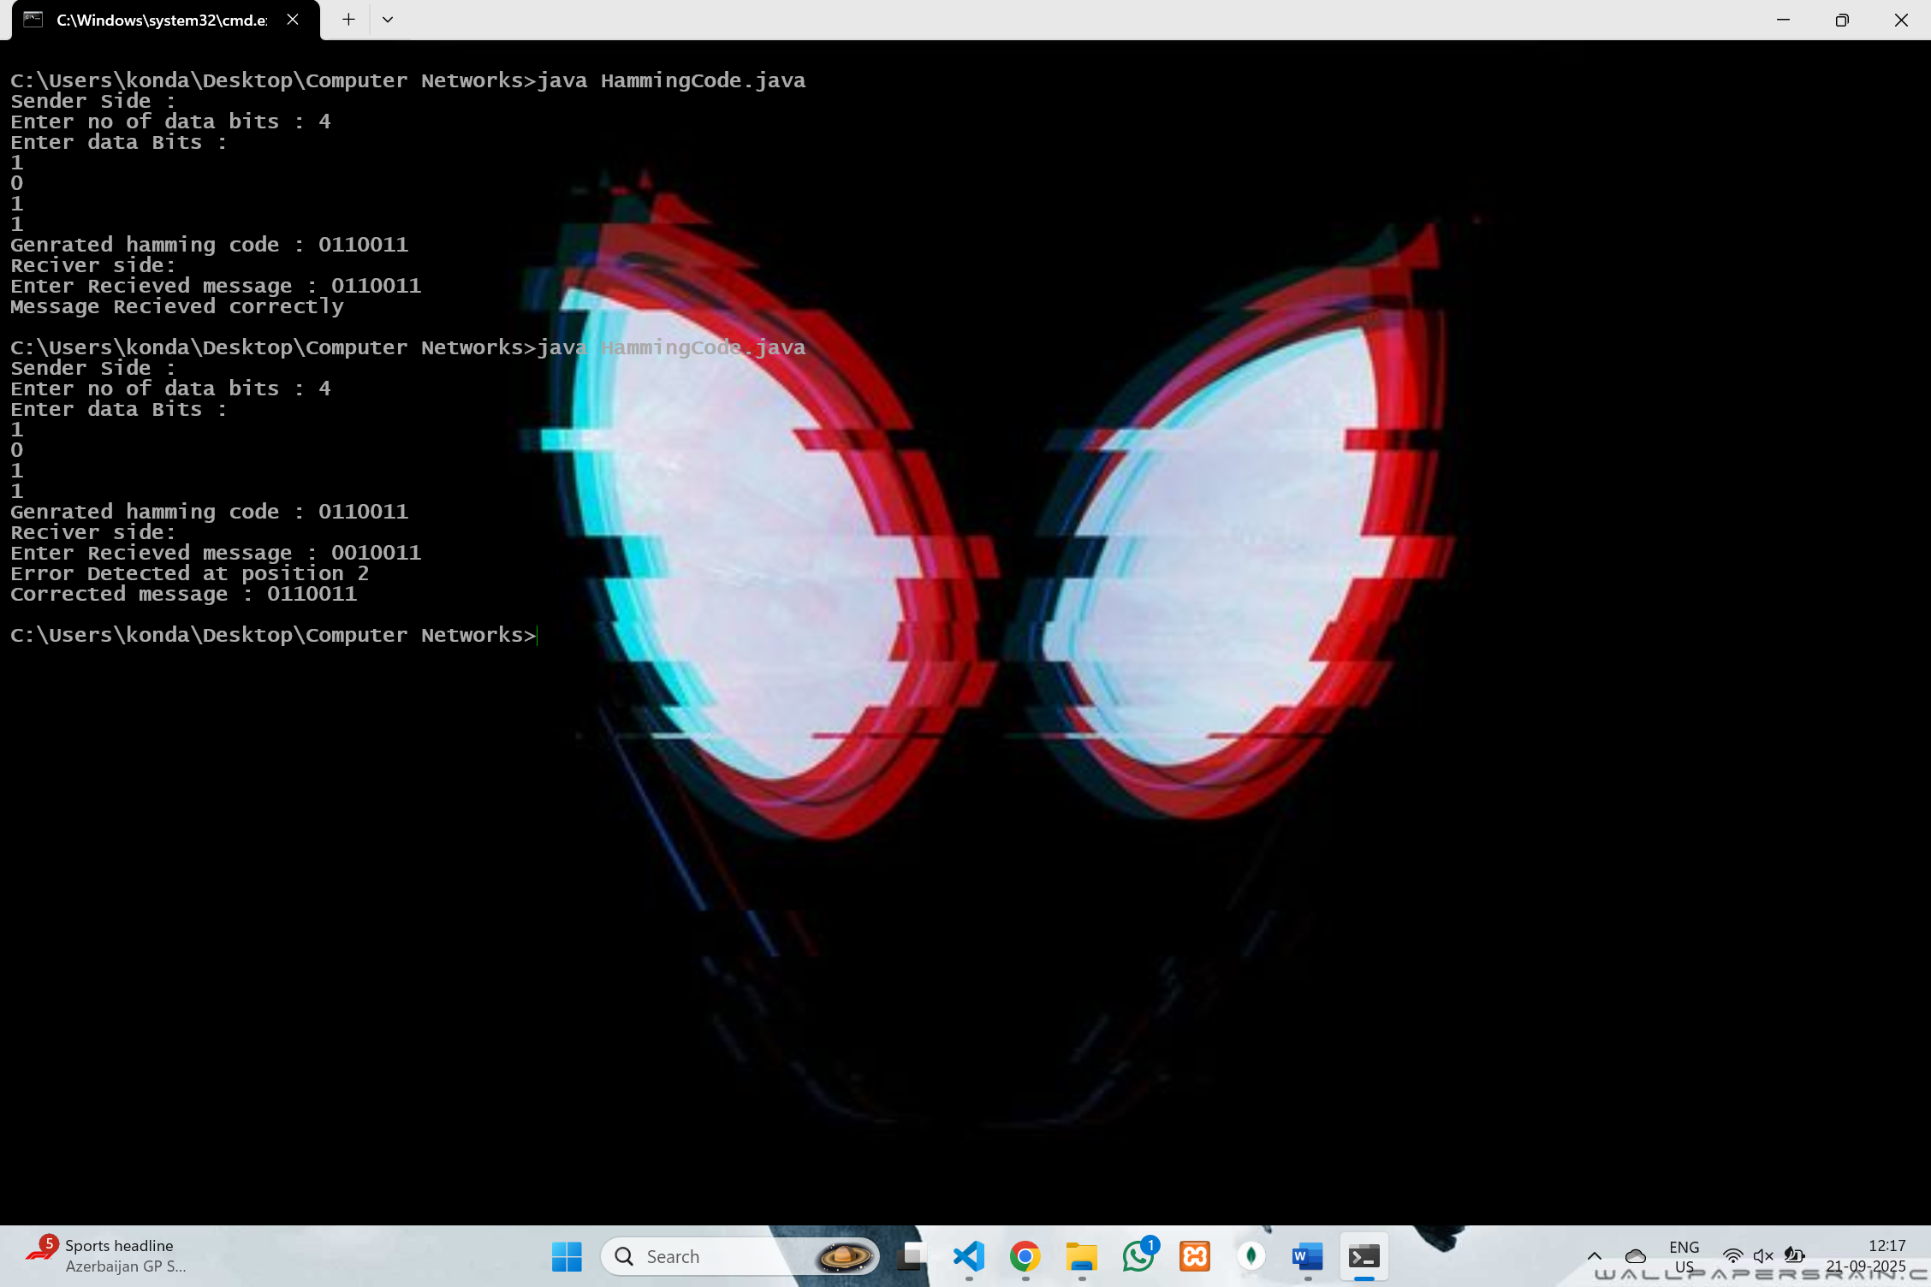

## 5. Develop a Program to implement on a data set of characters the three CRC polynomials – CRC 12, CRC 16 and CRC CCIP.

import java.util.**\***;

public class CRC {

    public static void main(String[] *args*) {

        Scanner sc = new Scanner(System.in);

System.out.print("Enter Frame Size : ");

        int frameSize = sc.nextInt();

        System.out.print("Enter Frame bits (Space Separated 0/1) : ");

        int[] frame = new int[frameSize];

        for (int i = 0; i < frameSize; i++) {

            frame[i] = sc.nextInt();

        }

System.out.print("Enter the Highest Power of x in the generator : ");

        int gp = sc.nextInt();

        int[] generator = new int[gp + 1];

        System.out.println("Enter Coefficient for Generator Polynomial :");

        for (int i = gp; i >= 0; i--) {

            System.out.print("Coefficient of x^" + i + " : ");

            generator[i] = sc.nextInt();

        }

int[] transmitted = new int[frameSize + gp];

        for (int i = 0; i < frameSize; i++) {

            transmitted[i] = frame[i];

        }

int[] remainder = divide(transmitted.clone(), generator);

System.out.println("Sender Side : ");

        System.out.print("Frame : ");

        for (int i = 0; i < frameSize; i++) System.out.print(frame[i]);

        System.out.println();

        System.out.print("Generator : ");

        for (int i = gp; i >= 0; i--) System.out.print(generator[i]);

        System.out.println();

        System.out.print("CRC : ");

        for (int i = 0; i < gp; i++) System.out.print(remainder[i]);

        System.out.println();

for (int i = 0; i < gp; i++) {

            transmitted[frameSize + i] = remainder[i];

        }

System.out.print("Transimitted Frame : ");

        for (int i = 0; i < transmitted.length; i++)

System.out.print(transmitted[i]);

        System.out.println();

System.out.println("Reciever SIde:");

        System.out.print("Enter Recieved Frame Size : ");

        int rsize = sc.nextInt();

        System.out.print("Enter Recieved Frame : ");

        int[] received = new int[rsize];

        for (int i = 0; i < rsize; i++) {

            received[i] = sc.nextInt();

        }

int[] rem2 = divide(received.clone(), generator);

        System.out.print("Remainder :");

        for (int i = 0; i < gp; i++) System.out.print(rem2[i]);

        System.out.println();

        boolean error = false;

        for (int i = 0; i < gp; i++) {

            if (rem2[i] != 0) {

                error = true;

                break;

            }

        }

        if (error) {

            System.out.println("Error Detected");

        } else {

            System.out.println("NO error Detected");

        }

sc.close();

    }

private static int[] divide(int[] *dividend*, int[] *divisor*) {

        int gp = *divisor*.length - 1;

        for (int i = 0; i <= *dividend*.length - *divisor*.length; i++) {

            if (*dividend*[i] == 1) {

                for (int j = 0; j < *divisor*.length; j++) {

*dividend*[i + j] ^= *divisor*[j];

                }

            }

        }

        int[] remainder = new int[gp];

        for (int i = 0; i < gp; i++) {

            remainder[i] = *dividend*[*dividend*.length - gp + i];

        }

        return remainder;

    } }

### Output :-

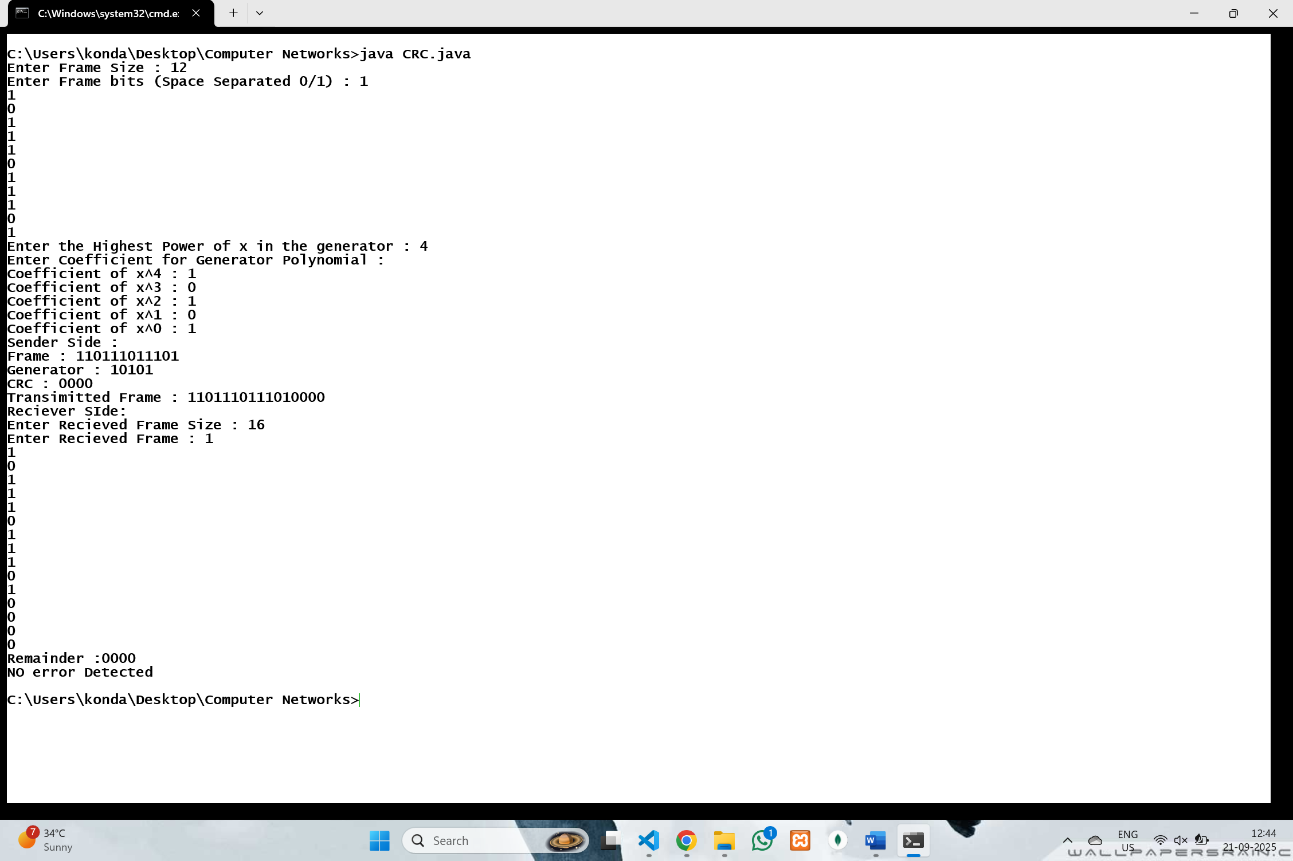

## 6. Develop a Program to implement Sliding window protocol for Goback N.

import java.util.**\***;

public class GoBackNARQ {

    private int totalFrames;

    private int windowSize;

    private int base = 0;

    private int nextFrame = 0;

    private long timerStart;

    private final int TIMEOUT = 3000;

    private boolean timerRunning = false;

    private Scanner sc = new Scanner(System.in);

public GoBackNARQ(int *totalFrames*, int *windowSize*) {

**this**.totalFrames = *totalFrames*;

**this**.windowSize = *windowSize*;

    }

public void SendFrames() {

        while (base < totalFrames) {

            while (nextFrame < base + windowSize && nextFrame < totalFrames) {

                System.out.println("Sending frame " + nextFrame);

                nextFrame++;

                if (!timerRunning) {

                    timerRunning = true;

                    timerStart = System.currentTimeMillis();

                }

            }

            System.out.print("Was Ack for frame " + base + " received ? (y/n) : ");

            String ackInput = sc.next();

if (ackInput.equals("y")) {

                System.out.println("Ack received for frame " + base);

                base++;

                if (base == nextFrame) {

                    timerRunning = false;

                } else {

                    timerStart = System.currentTimeMillis();

                }

            } else if (ackInput.equals("n")) {

                System.out.println("Ack for frame " + base + " is lost waiting for timeout...");

                try {

                    Thread.sleep(TIMEOUT);

                } catch (InterruptedException *e*) {

                    e.printStackTrace();

                }

                int end = Math.min(base + windowSize, totalFrames);

                System.out.println("Time Out ! Resending frames from " + base + " to " + (end - 1));

                for (int i = base; i < end; i++) {

                    System.out.println("Sending frame " + i);

                }

                nextFrame = end;

                timerStart = System.currentTimeMillis();

            } else {

                System.out.println("Invalid input please enter y or n");

            }

        }

        System.out.println("All frames are Acknowledged");

    }

    public static void main(String[] *args*) {

        Scanner sc = new Scanner(System.in);

        System.out.print("Enter total number of frames to send : ");

        int totalFrames = sc.nextInt();

        System.out.print("Enter Window Size : ");

        int windowSize = sc.nextInt();

        if (windowSize > totalFrames)

            windowSize = totalFrames;

        GoBackNARQ gbn = new GoBackNARQ(totalFrames, windowSize);

        gbn.SendFrames();

        sc.close();

    }}

### Output :-

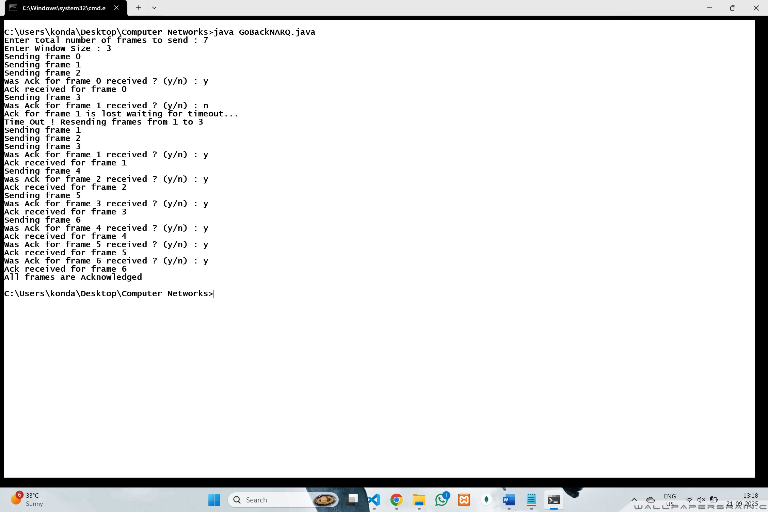

## 7. Develop a Program to implement Sliding window protocol for Selective repeat.

import java.util.**\***;

public class SelectiveRepeatProtocol {

    private final int totalFrames, windowSize;

    private final boolean[] sent, acked;

    private int base = 1;

public SelectiveRepeatProtocol(int *totalFrames*, int *windowSize*) {

**this**.totalFrames = *totalFrames*;

**this**.windowSize = *windowSize*;

**this**.sent = new boolean[*totalFrames* + 1];

**this**.acked = new boolean[*totalFrames* + 1];

    }

private void Sender(Scanner *sc*) {

        while (base <= totalFrames) {

            int windowEnd = Math.min(base + windowSize - 1, totalFrames);

            for (int i = base; i <= windowEnd; i++) {

                if (!sent[i]) {

                    Send(i);

                }

            }

            for (int f = base; f <= windowEnd; f++) {

                if (!acked[f]) {

                  System.out.print("Ack for frame " + f + " reicieved ? (y/n) :");

                    String response = *sc*.next().trim();

                    if (response.equalsIgnoreCase("y")) {

                        acked[f] = true;

                       System.out.println("Sender : Ack received for frame " + f);

                        while (base <= totalFrames && acked[base]) {

                            base++;

                        }

                    int nextToSend = Math.min(base + windowSize - 1, totalFrames);

                        if (nextToSend > windowEnd && nextToSend <= totalFrames) {

                            if (!sent[nextToSend]) {

                                Send(nextToSend);

                            }

                        } else if (base > totalFrames) {

                         System.out.println("Sender : there is no frame to send");

                        }

                    } else if (response.equalsIgnoreCase("n")) {

                        System.out.println("Sender:ack lost for frame" + f);

                        System.out.println("Resending frame " + f);

                        Send(f);

                    }

                }

            }

        }

    }

    private void Send(int *frameNo*) {

        System.out.println("Sender : Sending frame " + *frameNo*);

        sent[*frameNo*] = true;

        delay(100);

    }

    private void delay(int *ms*) {

        try {

            Thread.sleep(*ms*);

        } catch (InterruptedException *e*) {

            e.printStackTrace();

        }

    }

    public static void main(String[] *args*) {

        Scanner sc = new Scanner(System.in);

        System.out.print("Enter total number of frames : ");

        int totalFrames = sc.nextInt();

        System.out.print("Enter Window Size : ");

        int windowSize = sc.nextInt();

        SelectiveRepeatProtocol srp = new SelectiveRepeatProtocol(totalFrames, windowSize);

        srp.Sender(sc);

        sc.close(); } }

### Output :-

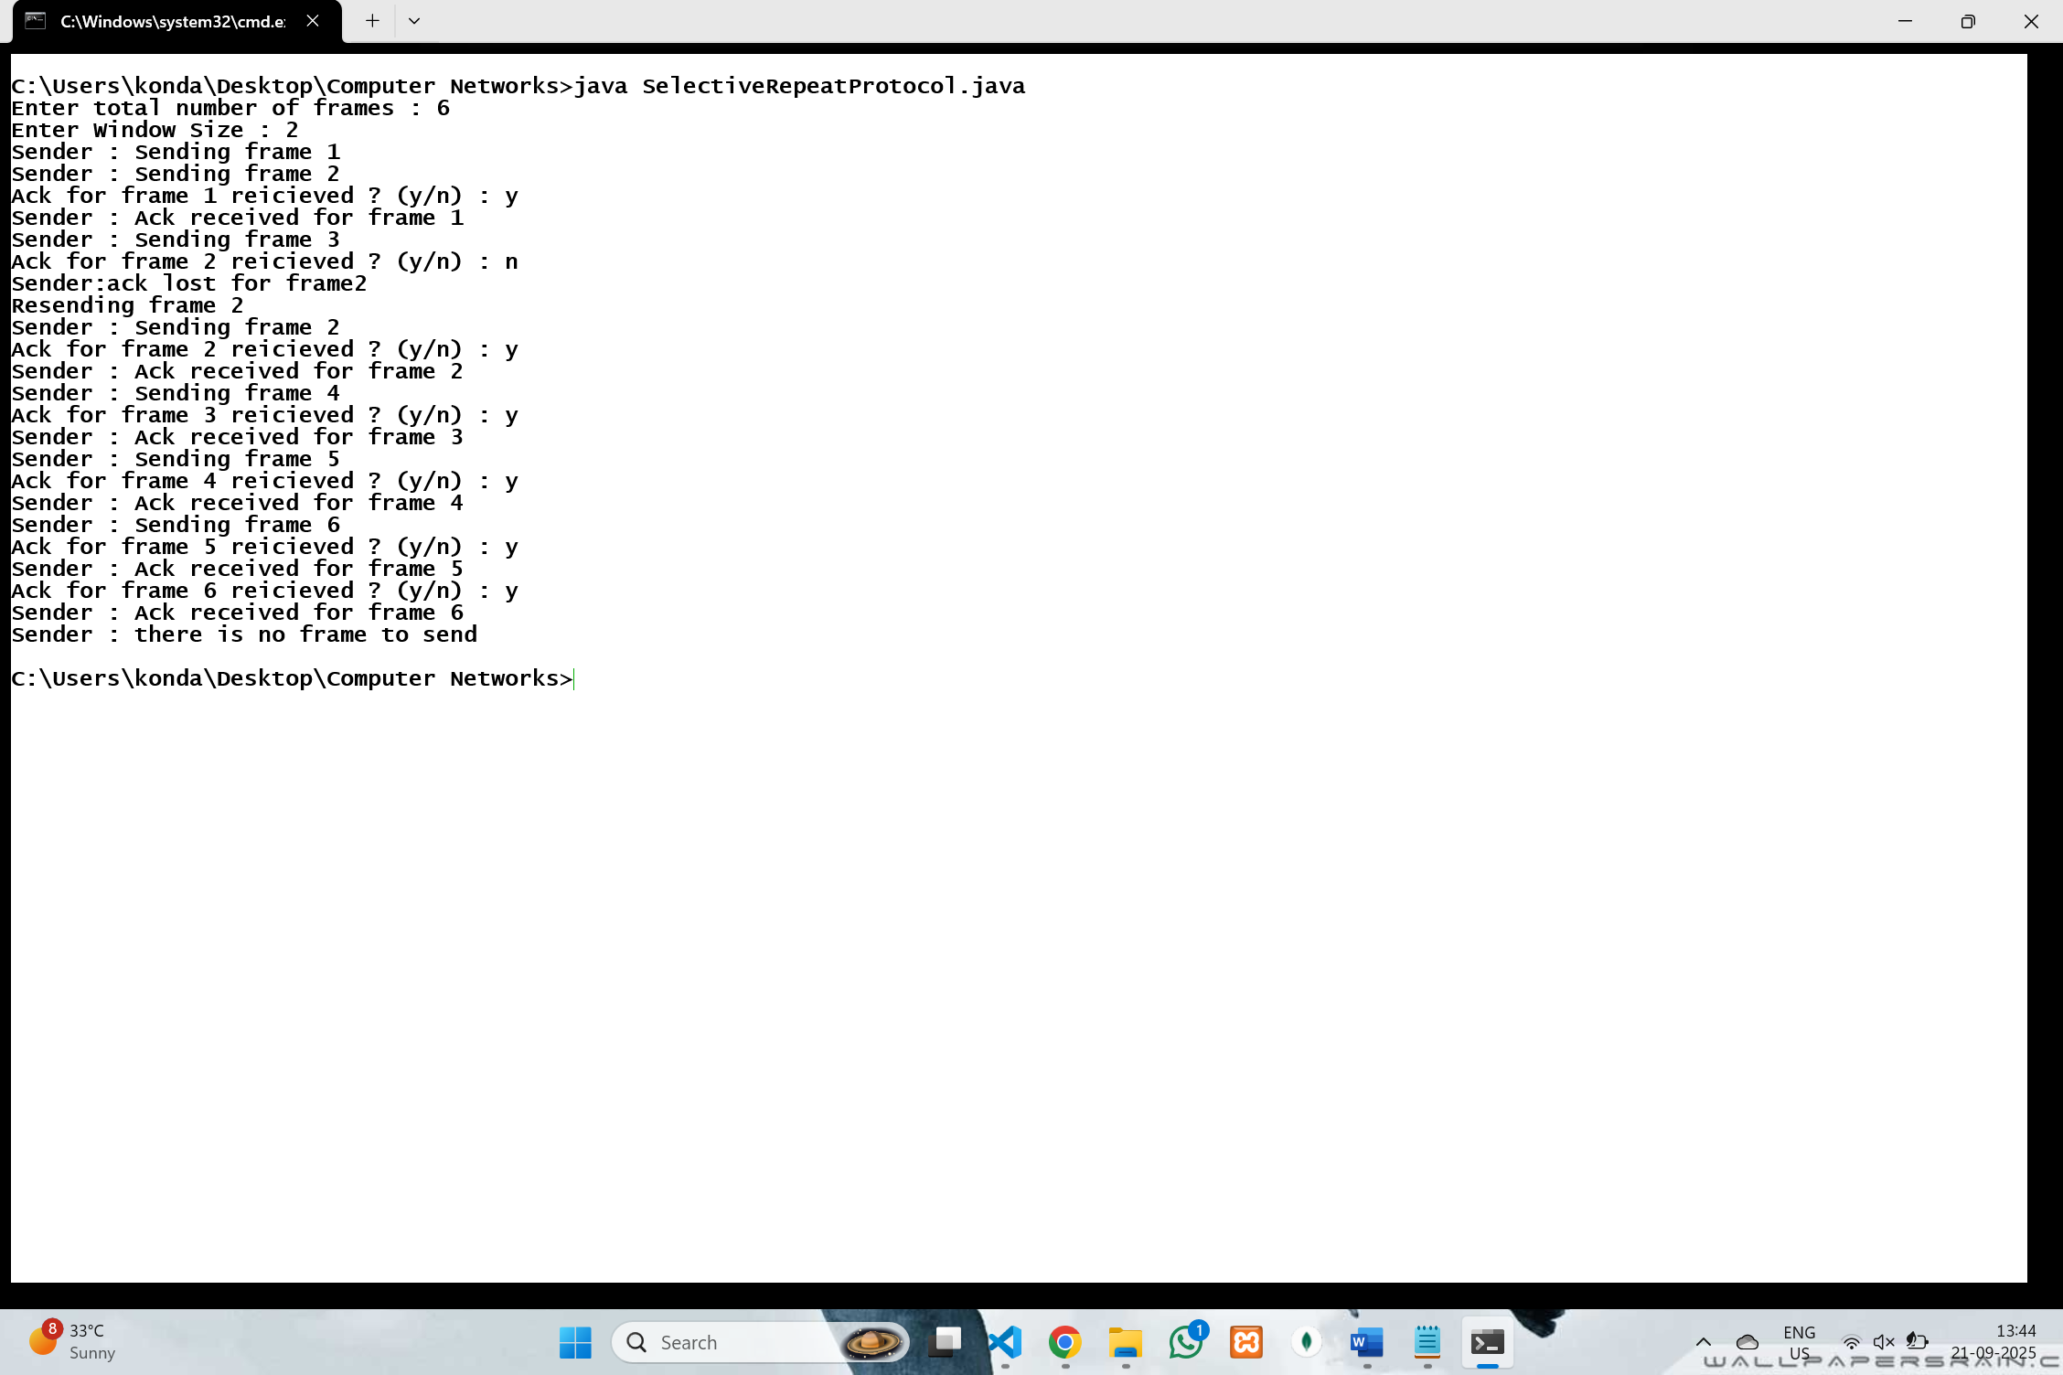

## 8. Develop a Program to implement Stop and Wait Protocol.

import java.util.**\***;

public class StopAndWaitProtocol {

    private final int totalFrames;

    private final int TIMEOUT = 3000;

    public StopAndWaitProtocol(int *totalFrames*) {

**this**.totalFrames = *totalFrames*;

    }

    public void sender(Scanner *sc*) {

        for (int frameNo = 1; frameNo <= totalFrames; frameNo++) {

            boolean ackReceived = false;

            while (!ackReceived) {

                System.out.println("Sender : Sending frame " + frameNo);

                delay(500);

                System.out.print("Was Ack for frame " + frameNo + " received ? (y/n) : ");

                String response = *sc*.next().trim();

                if (response.equalsIgnoreCase("y")) {

                    System.out.println("Sender : Ack received for frame " + frameNo);

                    ackReceived = true;

                } else if (response.equalsIgnoreCase("n")) {

                    System.out.println("Sender : Ack lost for frame " + frameNo + " waiting for timeout...");

                    try {

                        Thread.sleep(TIMEOUT);

                    } catch (InterruptedException *e*) {

                        e.printStackTrace();

                    }

                    System.out.println("Time Out ! Resending frame " + frameNo);

                } else {

                    System.out.println("Invalid input please enter y or n");

                }

            }

        }

        System.out.println("All frames sent and acknowledged successfully");

    }

    private void delay(int *ms*) {

        try {

            Thread.sleep(*ms*);

        } catch (InterruptedException *e*) {

            e.printStackTrace();

        }

    }

    public static void main(String[] *args*) {

        Scanner sc = new Scanner(System.in);

        System.out.print("Enter total number of frames to send : ");

        int totalFrames = sc.nextInt();

        StopAndWaitProtocol sap = new StopAndWaitProtocol(totalFrames);

        sap.sender(sc);

        sc.close();

    }

}

### Output :-

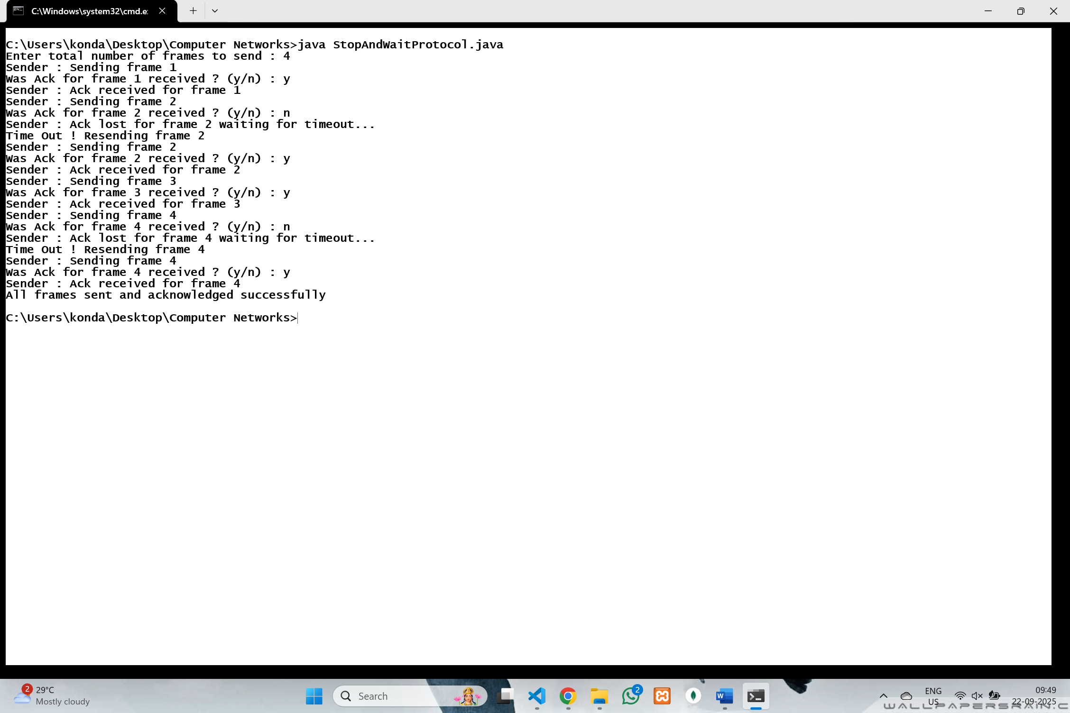

## 9. Develop a program for congestion control using leaky bucket algorithm .

#### import java.util.LinkedList;

#### import java.util.Queue;

#### import java.util.Scanner;

#### public class LeakyBucket

#### {

#### private int capacity;

#### private int leakRate;

#### private Queue<Integer> buffer;

#### public LeakyBucket(int *capacity*, int *leakRate*) {

#### **this**.capacity = *capacity*;

#### **this**.leakRate = *leakRate*;

#### **this**.buffer = new LinkedList<>();

#### }

#### public void addPackets(int *packets*) {

#### System.out.println("Incoming packets: " + *packets*);

#### System.out.println("Buffer size before adding: " + buffer.size());

#### int dropped = 0;

#### int added = 0;

#### for (int i = 0; i < *packets*; i++) {

#### if (buffer.size() < capacity) {

#### buffer.add(1);

#### added++;

#### System.out.println("Packet added to bucket. Current size: " + buffer.size());

#### } else {

#### dropped++;

#### }

#### }

#### System.out.println("Packets added: " + added);

#### if (dropped > 0) {

#### System.out.println("Bucket overflow! Packets dropped: " + dropped);

#### }

#### }

#### public void leak() {

#### int leaked = 0;

#### for (int i = 0; i < leakRate; i++) {

#### if (!buffer.isEmpty()) {

#### buffer.poll();

#### leaked++;

#### }

#### }

#### System.out.println("Packets processed (leaked): " + leaked);

#### System.out.println("Buffer size after leaking: " + buffer.size());

#### System.out.println("---------------------------------------------------");

#### }

#### public static void main(String[] *args*) {

#### Scanner sc = new Scanner(System.in);

#### System.out.print("Enter bucket size (capacity): ");

#### int capacity = sc.nextInt();

#### System.out.print("Enter leak rate (packets processed per unit time): ");

#### int leakRate = sc.nextInt();

#### LeakyBucket leakyBucket = new LeakyBucket(capacity, leakRate);

#### System.out.println("\nStarting simulation. Enter -1 to stop.");

#### while (true) {

#### System.out.print("Enter incoming packets: ");

#### int packets = sc.nextInt();

#### if (packets == -1) {

#### System.out.println("Simulation ended.");

#### break;

#### }

#### leakyBucket.addPackets(packets);

#### leakyBucket.leak();

#### }

#### sc.close();

#### }

#### }

### Output :-

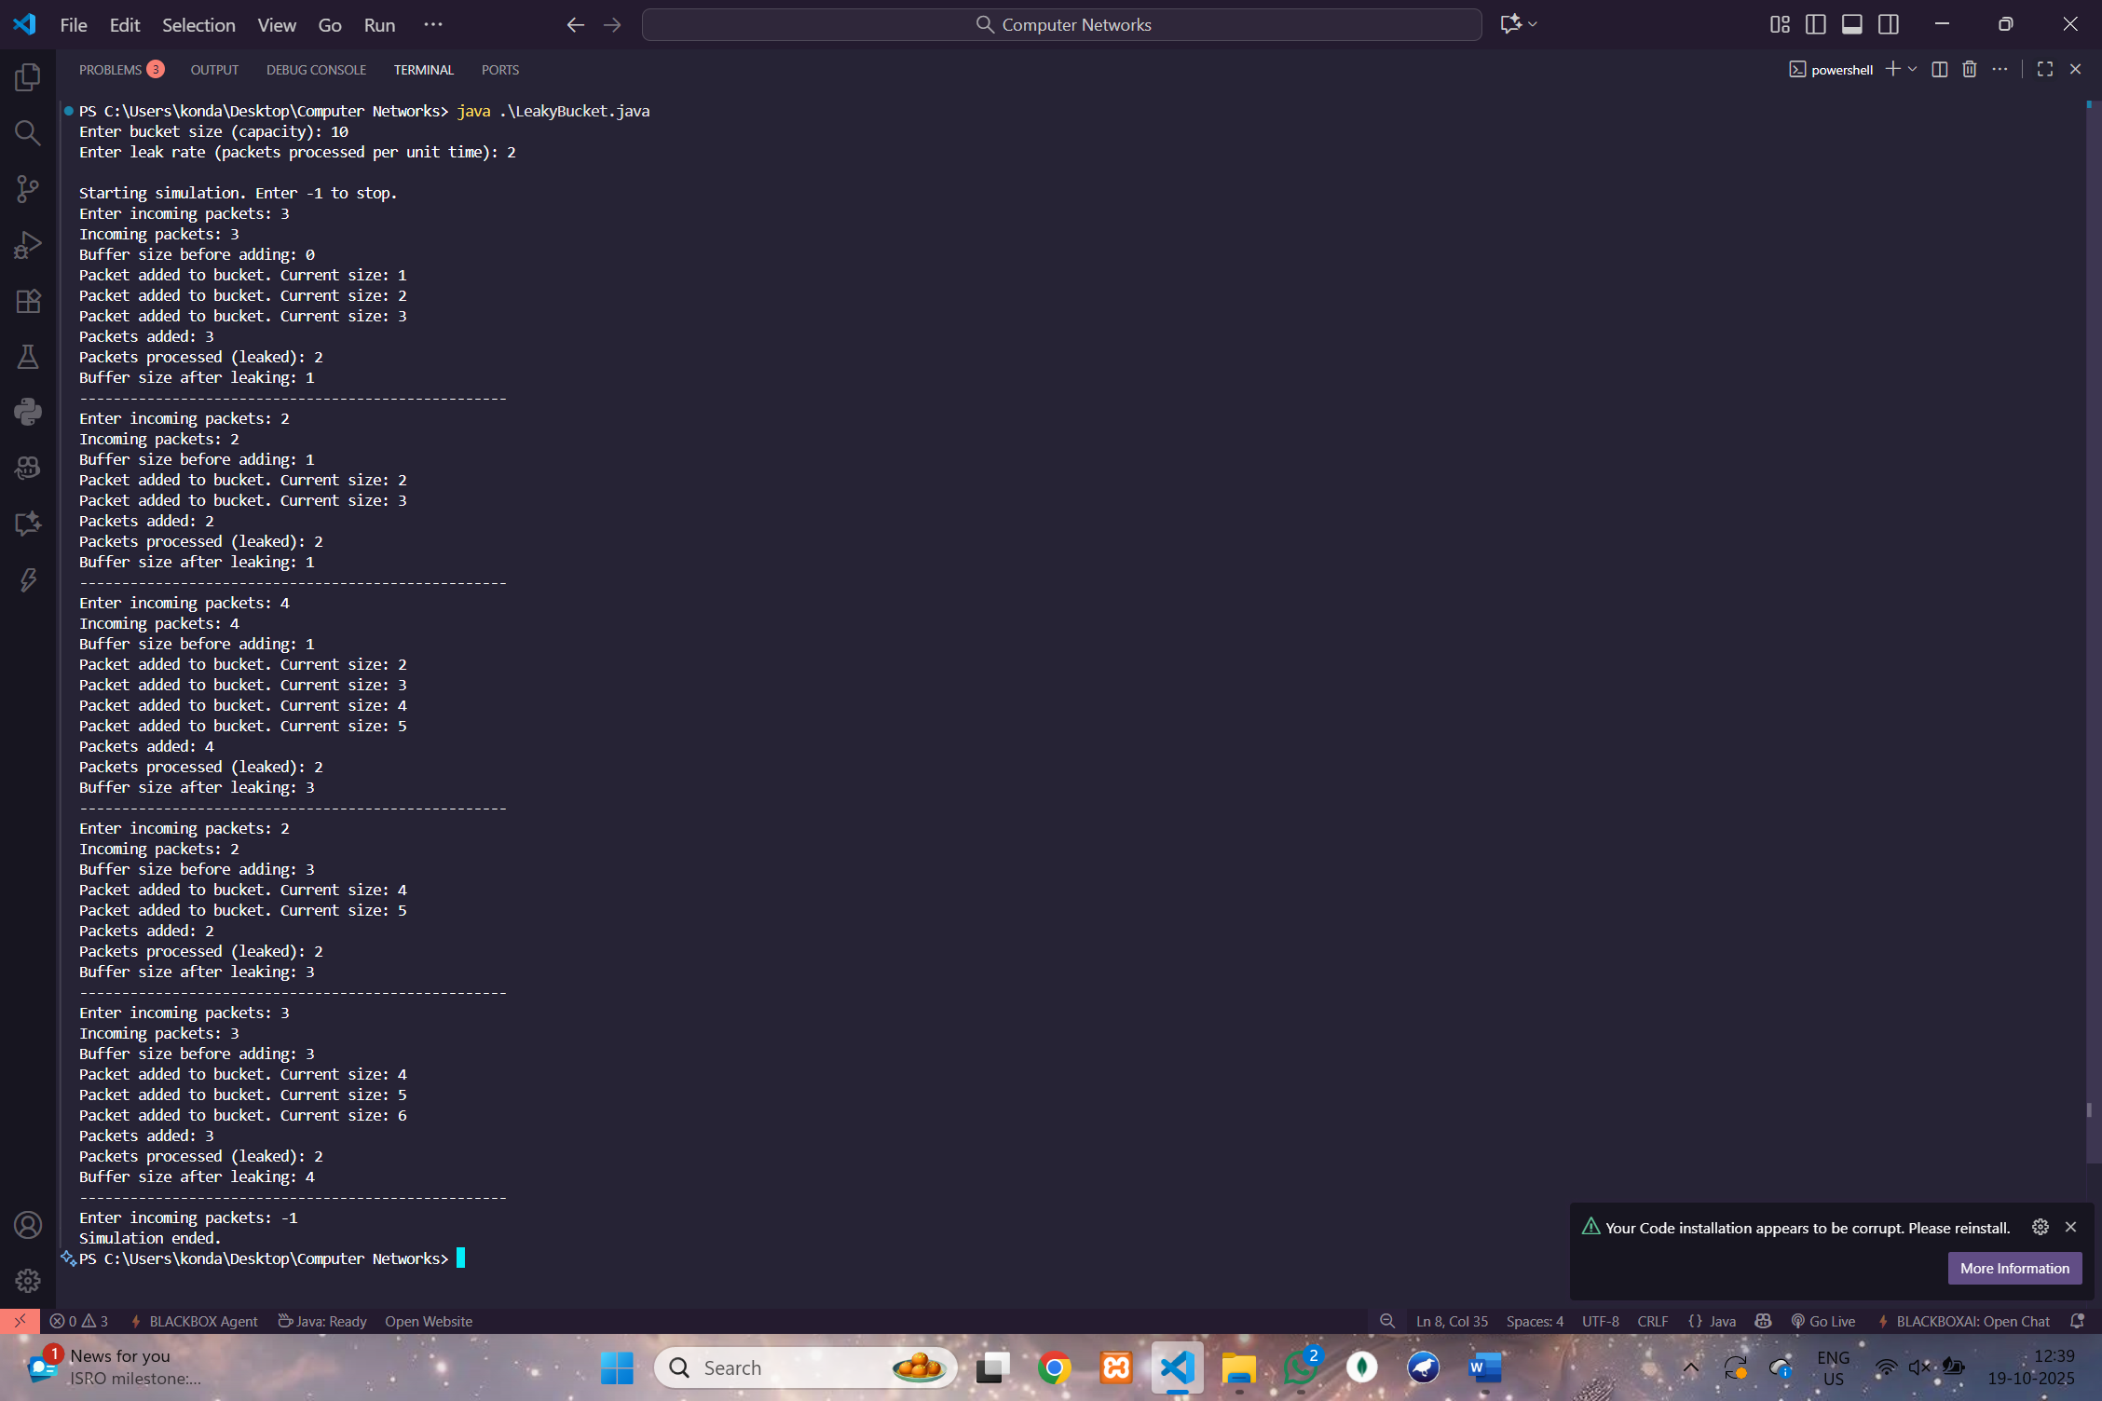

## 10. Develop a Program to implement Dijkstra‗s algorithm to compute the Shortest path through a graph.

#### import java.util.**\***;

#### public class Dijkstra {

#### public static void main(String[] *args*) {

#### Scanner sc = new Scanner(System.in);

#### System.out.println("Enter No of Vertices :");

#### int n = sc.nextInt();

#### sc.nextLine();

#### char[] arr = new char[n];

#### Map<Character, Integer> vertexMap = new HashMap<>();

#### for (int i = 0; i < n; i++) {

#### System.out.println("Enter the name of Vertex " + i + ":");

#### arr[i] = sc.next().charAt(0);

#### vertexMap.put(arr[i], i);

#### }

#### List<int[]> edges = new ArrayList<>();

#### System.out.println("Enter the number of edges:");

#### int e = sc.nextInt();

#### sc.nextLine();

#### for (int i = 0; i < e; i++) {

#### System.out.print("Enter edge (e.g., a -> b): ");

#### String edge = sc.nextLine();

#### String[] parts = edge.split("->");

#### if (parts.length != 2) {

#### System.out.println("Invalid input format. Use 'a -> b'.");

#### return;

#### }

#### char u = parts[0].trim().charAt(0);

#### char v = parts[1].trim().charAt(0);

#### if (!vertexMap.containsKey(u) || !vertexMap.containsKey(v)) {

#### System.out.println("Invalid vertices. Ensure they are within the vertex list.");

#### return;

#### }

#### System.out.print("Enter the weight for edge " + u + " -> " + v + ": ");

#### int w = sc.nextInt();

#### sc.nextLine();

#### if (w < 0) {

#### System.out.println("Negative weights are not allowed in Dijkstra's algorithm.");

#### return;

#### }

#### edges.add(new int[]{vertexMap.get(u), vertexMap.get(v), w});

#### }

#### if (n <= 0) {

#### System.out.println("Number of vertices must be positive.");

#### return;

#### }

#### int[] dist = new int[n];

#### boolean[] visited = new boolean[n];

#### int[] prev = new int[n];

#### Arrays.fill(dist, Integer.MAX_VALUE);

#### Arrays.fill(visited, false);

#### Arrays.fill(prev, -1);

#### System.out.print("Enter the source vertex (e.g., a): ");

#### char sourceChar = sc.next().charAt(0);

#### int src = vertexMap.get(sourceChar);

#### dist[src] = 0;

#### PriorityQueue<int[]> pq = new PriorityQueue<>((*a*, *b*) -> *a*[1] - *b*[1]);

#### pq.add(new int[]{src, 0});

#### List<List<int[]>> adj = new ArrayList<>(n);

#### for (int i = 0; i < n; i++) {

#### adj.add(new ArrayList<>());

#### }

#### for (int[] edge : edges) {

#### adj.get(edge[0]).add(new int[]{edge[1], edge[2]});

#### }

#### while (!pq.isEmpty()) {

#### int[] curr = pq.poll();

#### int u = curr[0];

#### int d = curr[1];

#### if (visited[u]) continue;

#### visited[u] = true;

#### for (int[] neighbor : adj.get(u)) {

#### int v = neighbor[0];

#### int w = neighbor[1];

#### if (dist[v] > dist[u] + w) {

#### dist[v] = dist[u] + w;

#### prev[v] = u;

#### pq.add(new int[]{v, dist[v]});

#### }

#### }

#### }

#### System.out.print("Enter the destination vertex (e.g., b): ");

#### char destChar = sc.next().charAt(0);

#### int dest = vertexMap.get(destChar);

#### if (dist[dest] == Integer.MAX_VALUE) {

#### System.out.println("Destination " + destChar + " is unreachable from " + sourceChar);

#### } else {

#### System.out.println("Shortest path from " + sourceChar + " to " + destChar + ":");

#### List<Character> path = new ArrayList<>();

#### int current = dest;

#### while (current != -1) {

#### path.add(arr[current]);

#### current = prev[current];

#### }

#### Collections.reverse(path);

#### for (char c : path) {

#### System.out.print(c + " ");

#### }

#### System.out.println();

#### System.out.println("Total cost: " + dist[dest]);

#### }

#### }

#### 

#### }

**Output :-**

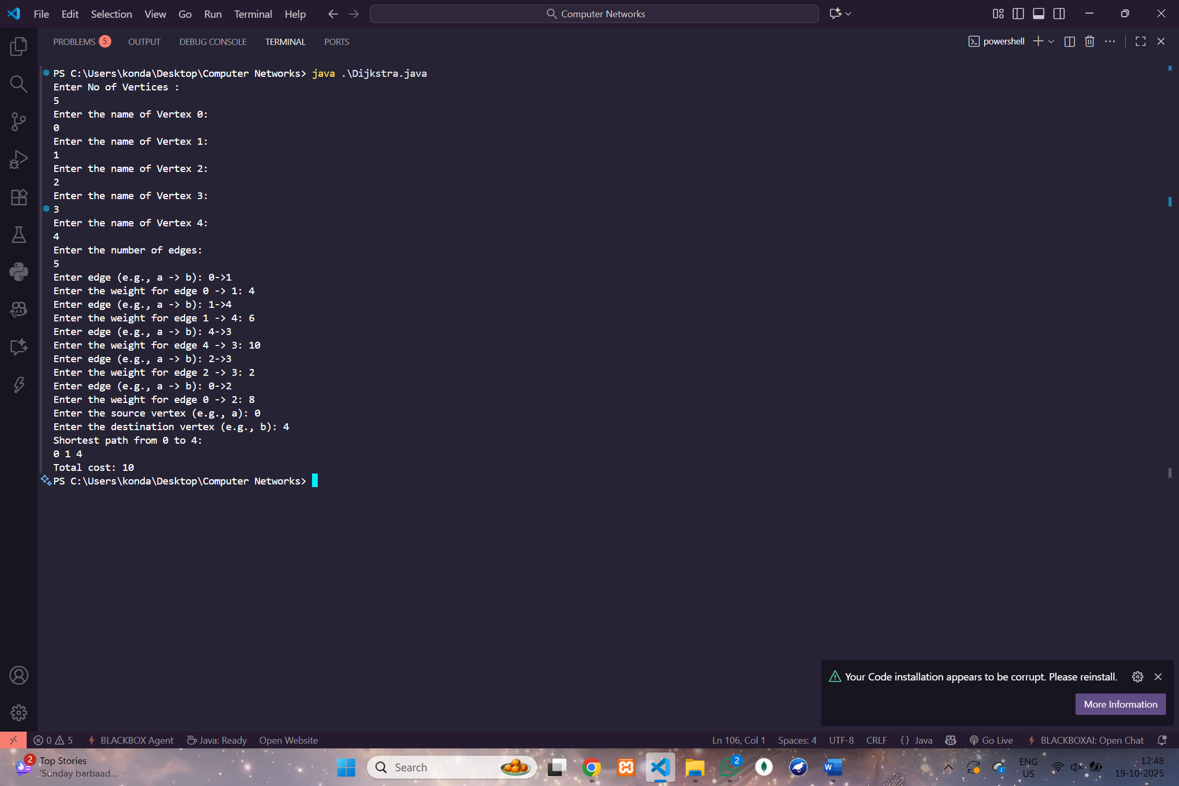

## 11. Develop a Program to implement Distance vector routing algorithm by obtaining routing table at each node (Take an example subnet graph with weights indicating delay between nodes).

#### import java.util.**\***;

#### public class DistanceVectorRouting{

#### static final int INF=9999;

#### public static void main(String[] *args*){

#### Scanner sc=new Scanner(System.in);

#### System.out.print("Enter number of nodes: ");

#### int n=sc.nextInt();

#### int[][] graph=new int[n][n];

#### System.out.println("Enter adjacency matrix (use -1 for no direct link):");

#### for(int i=0;i<n;i++){

#### for(int j=0;j<n;j++){

#### int val=sc.nextInt();

#### graph[i][j]=(val==-1)?INF:val;

#### }

#### }

#### int[][] cost=new int[n][n];

#### int[][] nextHop=new int[n][n];

#### for(int i=0;i<n;i++){

#### for(int j=0;j<n;j++){

#### cost[i][j]=graph[i][j];

#### if(graph[i][j]!=INF&&i!=j) nextHop[i][j]=j;

#### else nextHop[i][j]=-1;

#### }

#### cost[i][i]=0;

#### nextHop[i][i]=i;

#### }

#### boolean updated;

#### do{

#### updated=false;

#### for(int i=0;i<n;i++){

#### for(int j=0;j<n;j++){

#### for(int k=0;k<n;k++){

#### if(cost[i][k]!=INF&&cost[k][j]!=INF&&cost[i][k]+cost[k][j]<cost[i][j]){

#### cost[i][j]=cost[i][k]+cost[k][j];

#### nextHop[i][j]=nextHop[i][k];

#### updated=true;

#### }

#### }

#### }

#### }

#### }while(updated);

#### System.out.println("\nRouting tables for all nodes:");

#### for(int node=0;node<n;node++){

#### printRoutingTable(node,cost,nextHop,n);

#### }

#### System.out.print("\nEnter source node: ");

#### int src=sc.nextInt();

#### if(src<0||src>=n){

#### System.out.println("Invalid source node.");

#### sc.close();

#### return;

#### }

#### System.out.print("Enter destination node: ");

#### int dest=sc.nextInt();

#### if(dest<0||dest>=n){

#### System.out.println("Invalid destination node.");

#### sc.close();

#### return;

#### }

#### if(cost[src][dest]==INF){

#### System.out.println("No path exists from "+src+" to "+dest);

#### }else{

#### System.out.print("Path from node "+src+" to node "+dest+": ");

#### printPath(src,dest,nextHop);

#### System.out.println();

#### }

#### sc.close();

#### }

#### static void printPath(int *src*,int *dest*,int[][] *nextHop*){

#### System.out.print(*src*);

#### while(*src*!=*dest*){

#### *src*=*nextHop*[*src*][*dest*];

#### System.out.print(" -> "+*src*);

#### }

#### }

#### static void printRoutingTable(int *node*,int[][] *cost*,int[][] *nextHop*,int *n*){

#### System.out.println("\nRouting table for node "+*node*+":");

#### System.out.println("Destination\tCost\tNext Hop");

#### for(int j=0;j<*n*;j++){

#### if(*cost*[*node*][j]==INF) System.out.println(j+"\t\tINF\t-");

#### else System.out.println(j+"\t\t"+*cost*[*node*][j]+"\t"+*nextHop*[*node*][j]);

#### }

#### } }

**Output :-**

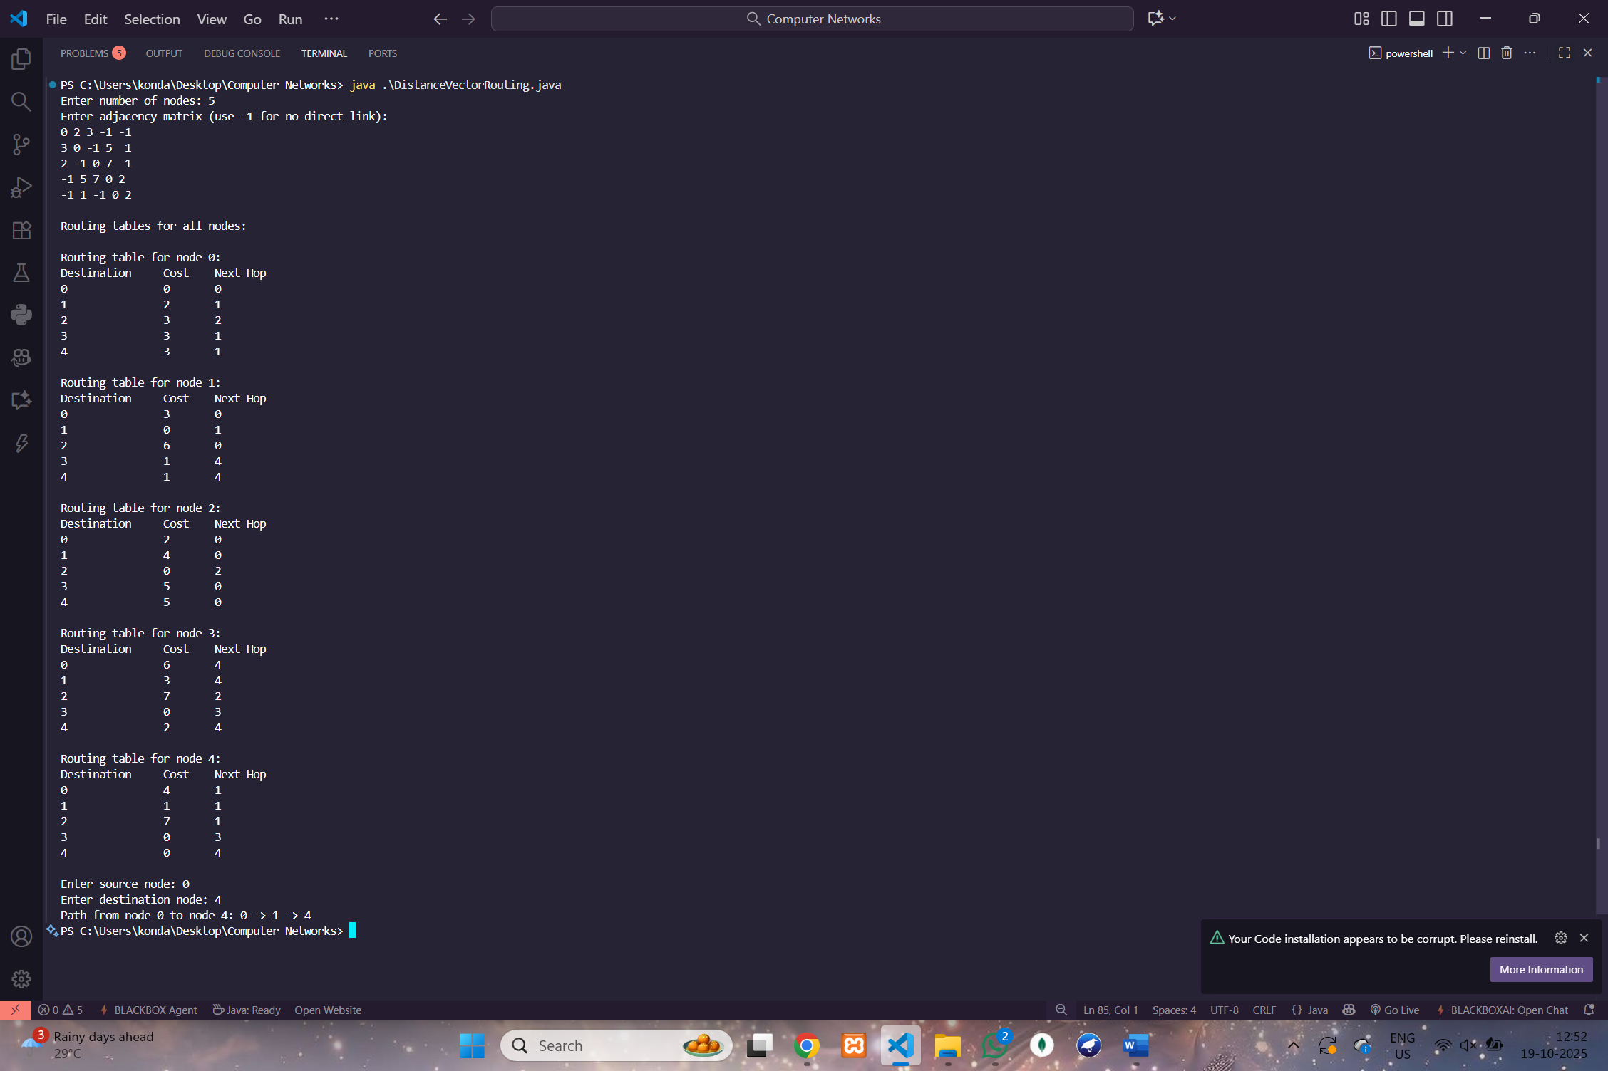

## 12. Wireshark

## Packet Capture Using Wire shark

## Starting Wire shark

## Viewing Captured Traffic

## Analysis and Statistics & Filters.

**i). Packet Capture:**

## ii). Starting Wire shark

* Launch Wireshark from the Start menu (Windows/Linux) or Applications folder (Mac).
* Confirm it is running and the interface selection screen is visible.

: Wireshark startup screen with interface list.

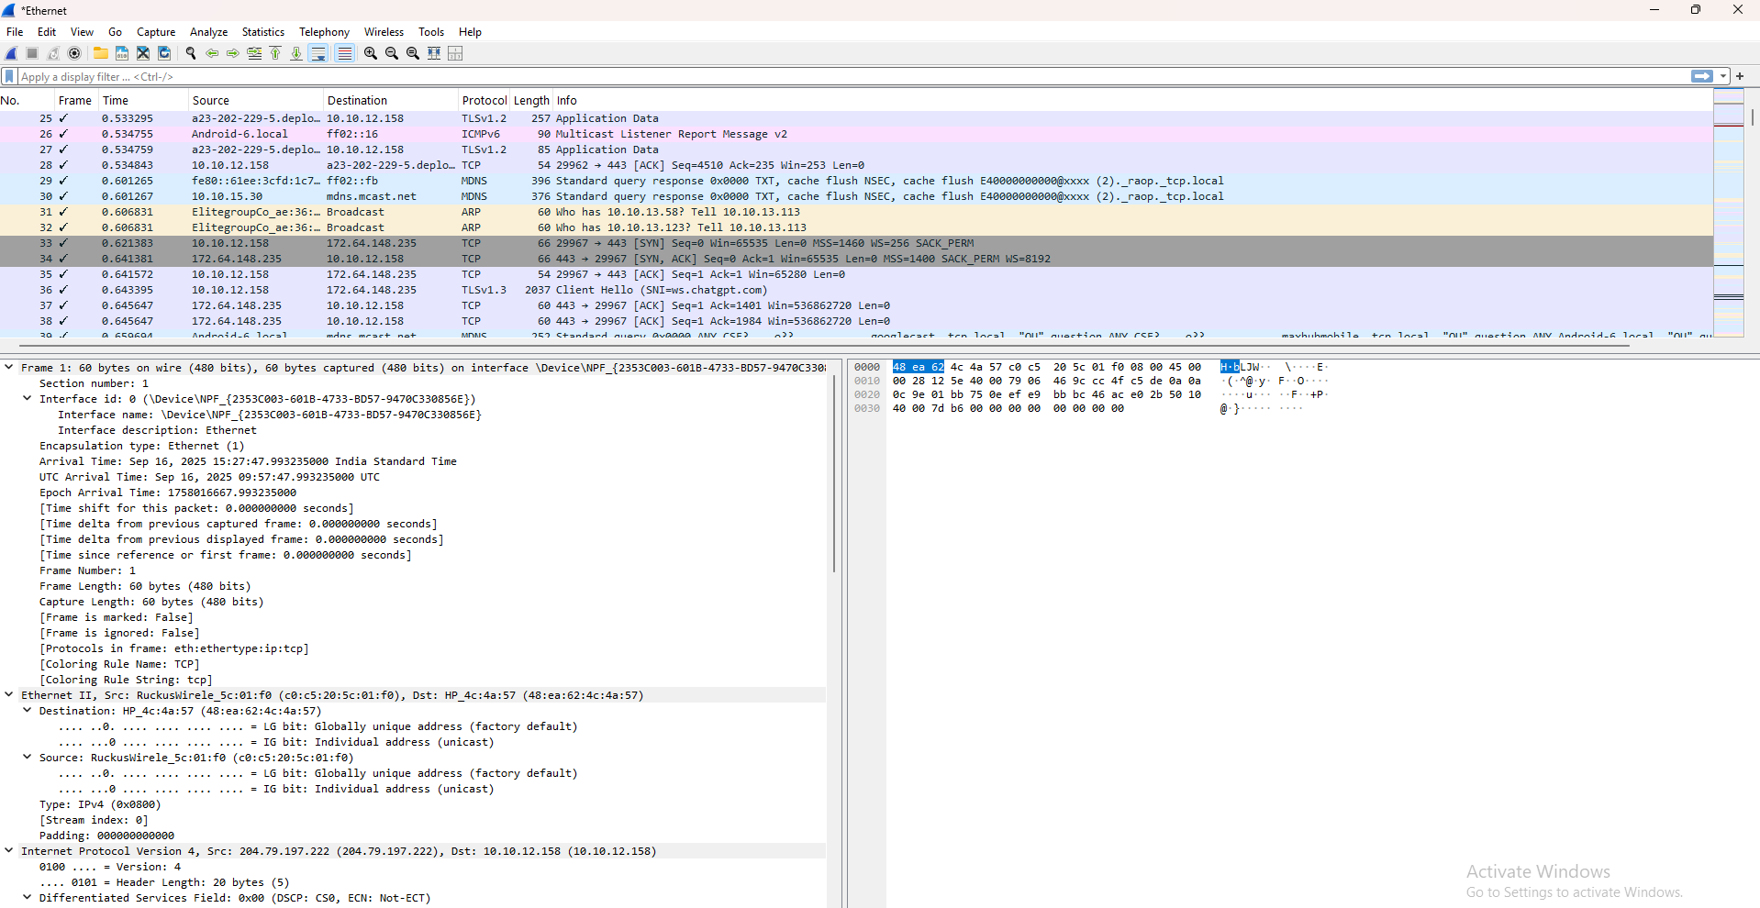

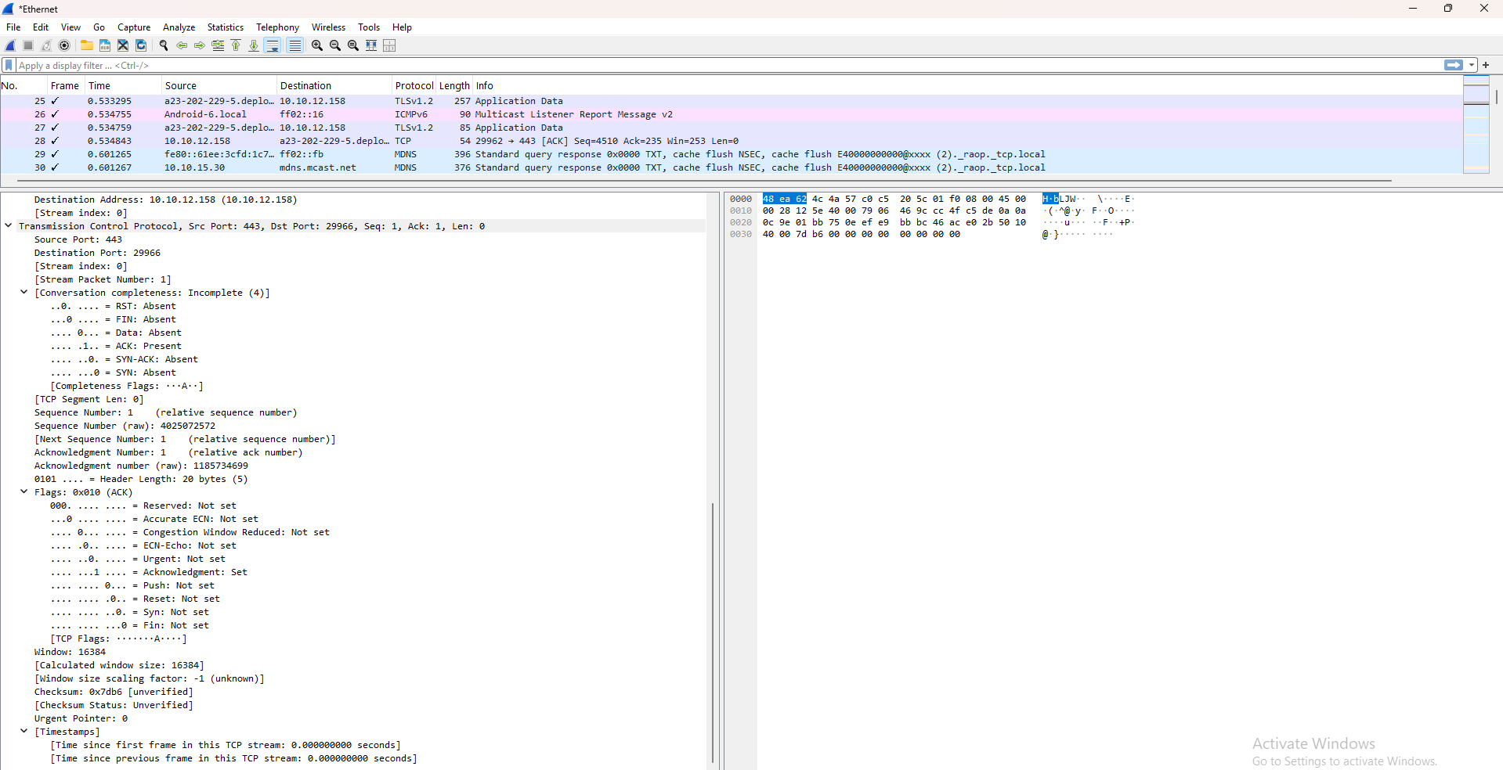

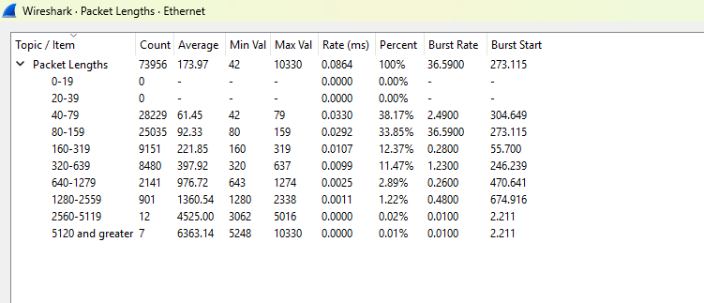

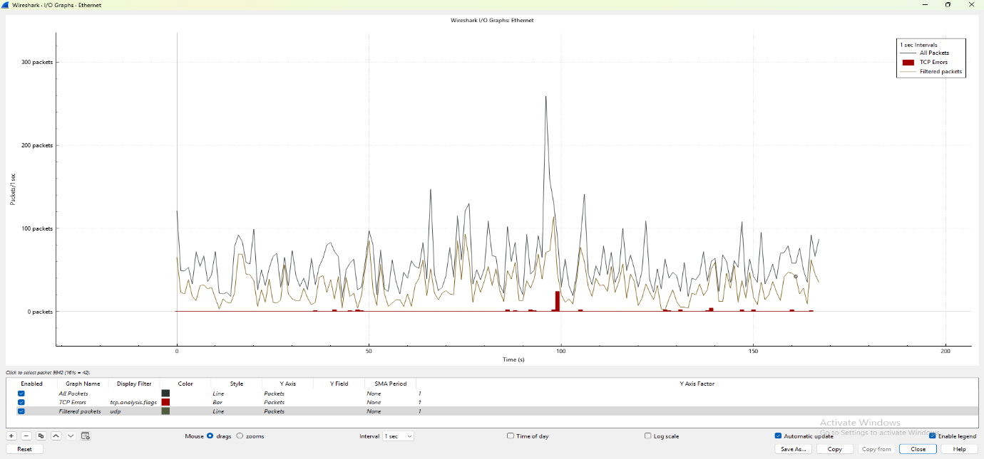

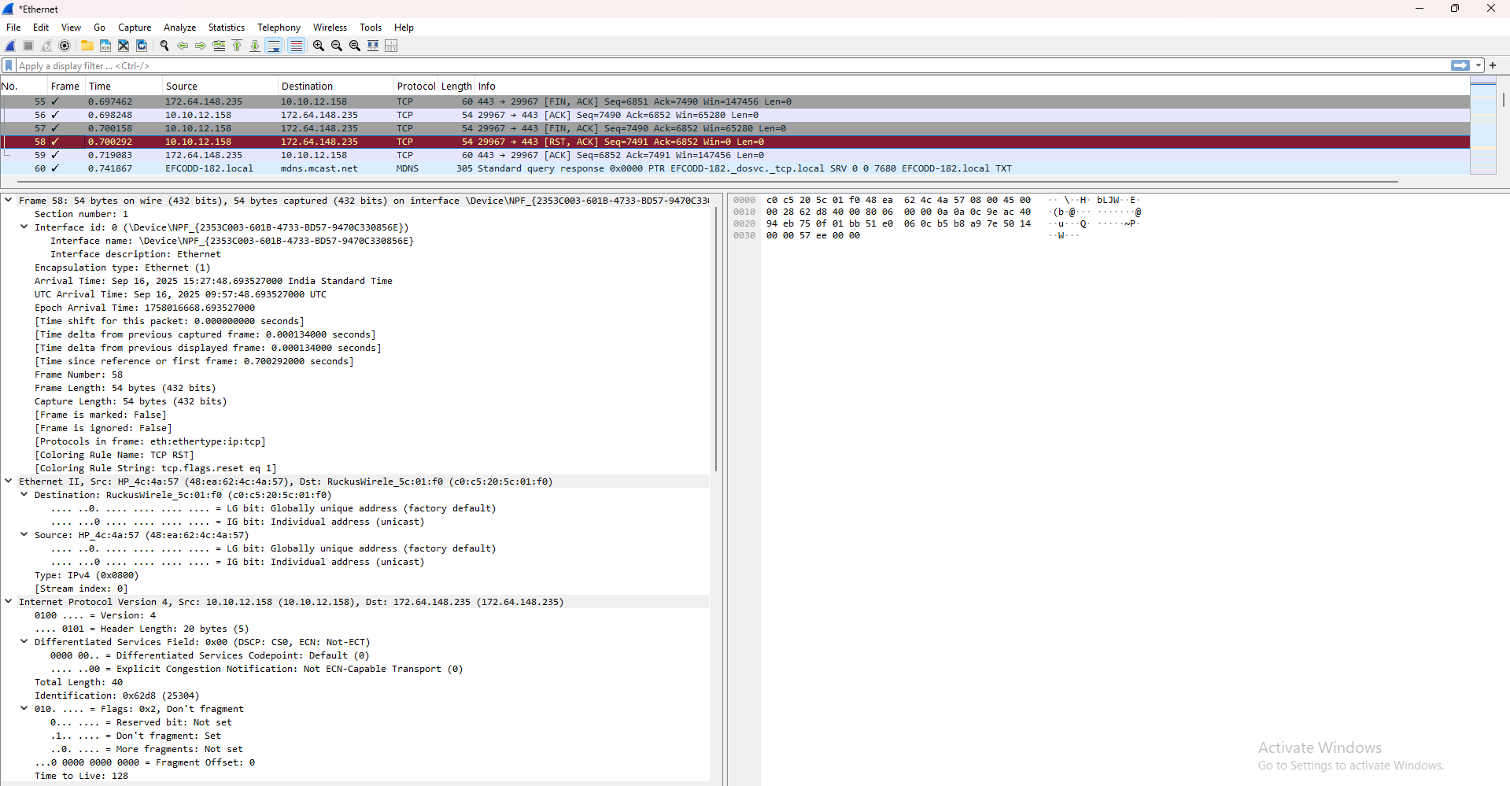

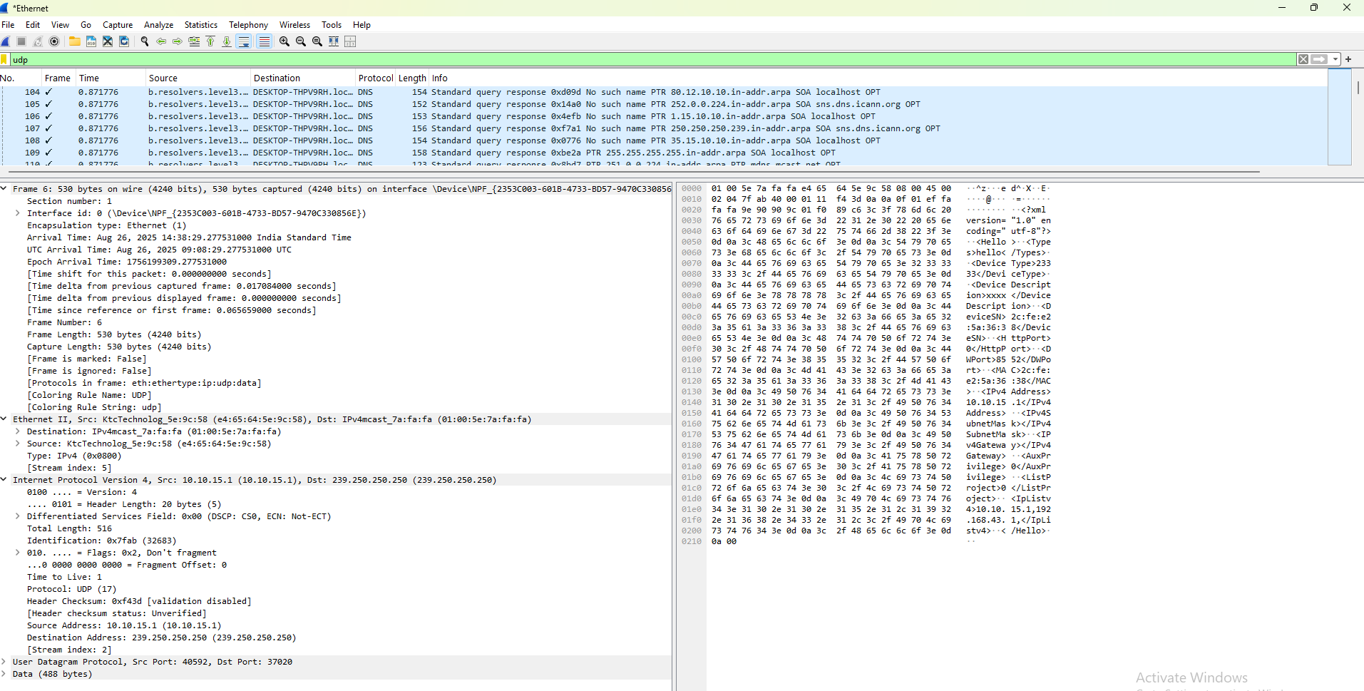

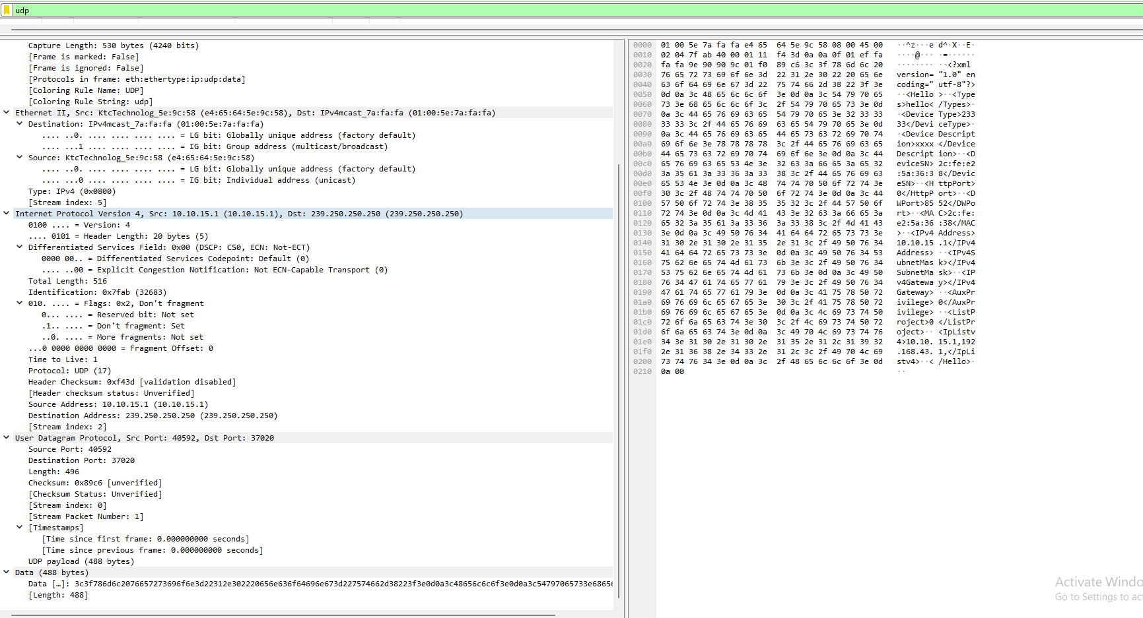

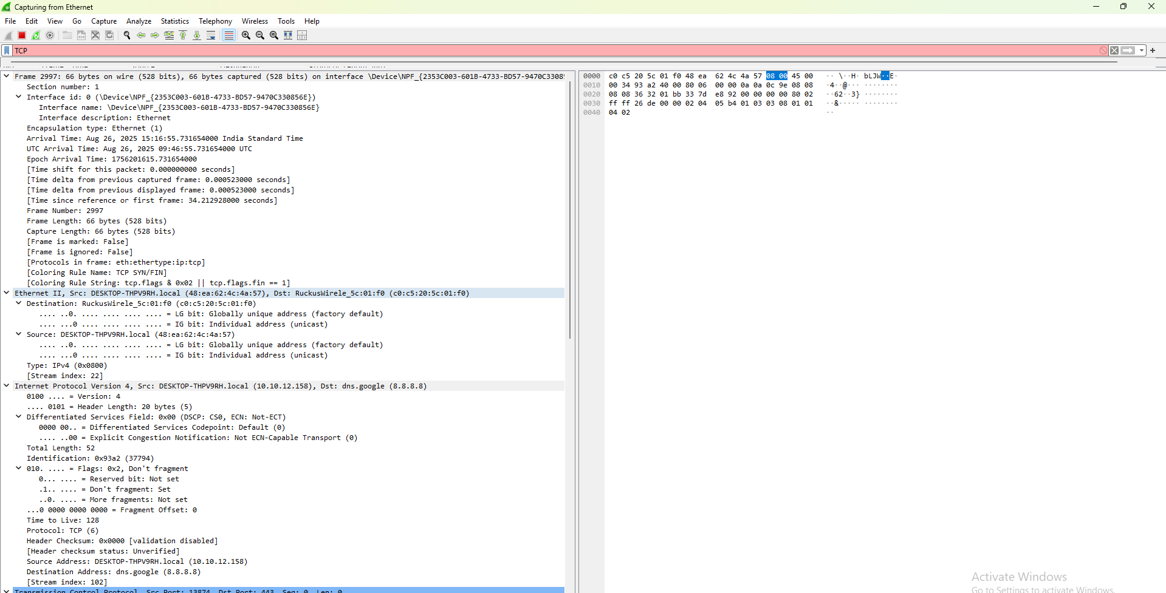

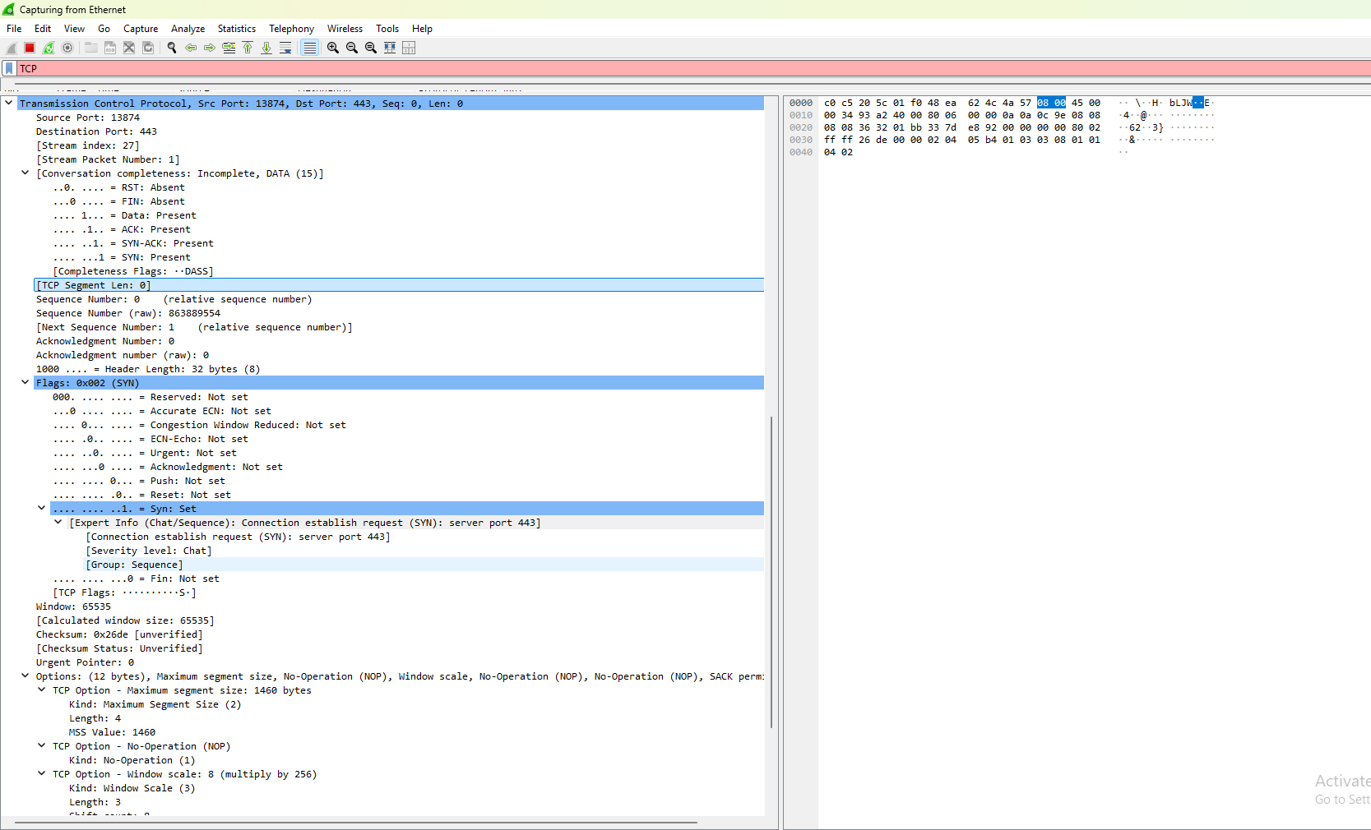

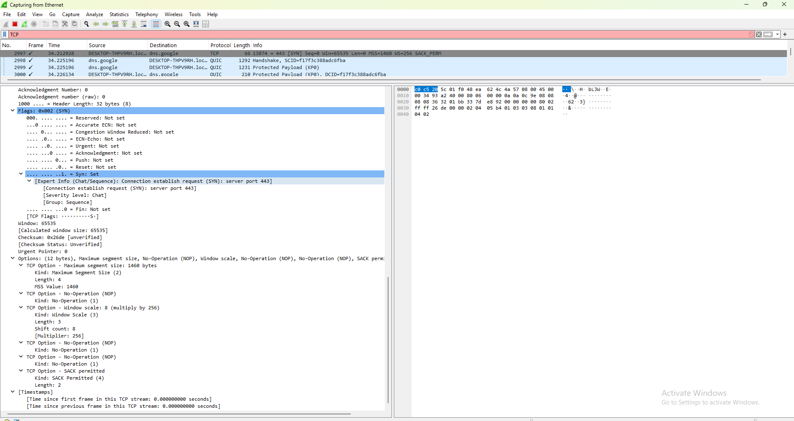

## 13. Discover active hosts, open ports and running services in a network using Nmap

**i) Discover active hosts using Nmap**:

**Command** :- *nmap -sn <IP Address>*

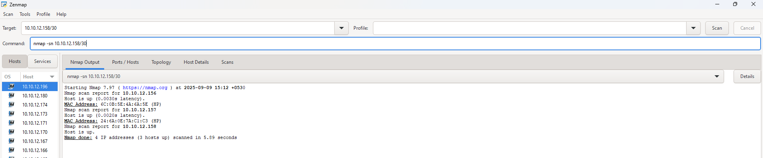

**ii) To find no.of open ports in the system**

**Command** :- *nmap -p 1-65535 <IP Address>*

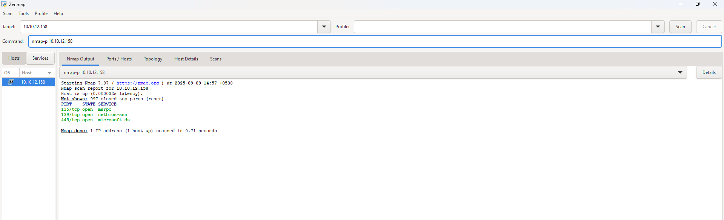

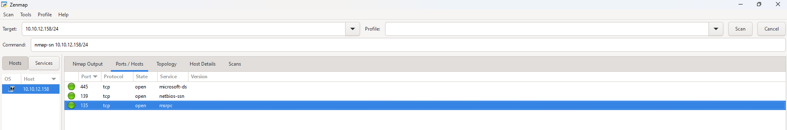

**iii)To find Running services and versions using Nmap:**

**Command** :- *nmap -sV <IP Address>*

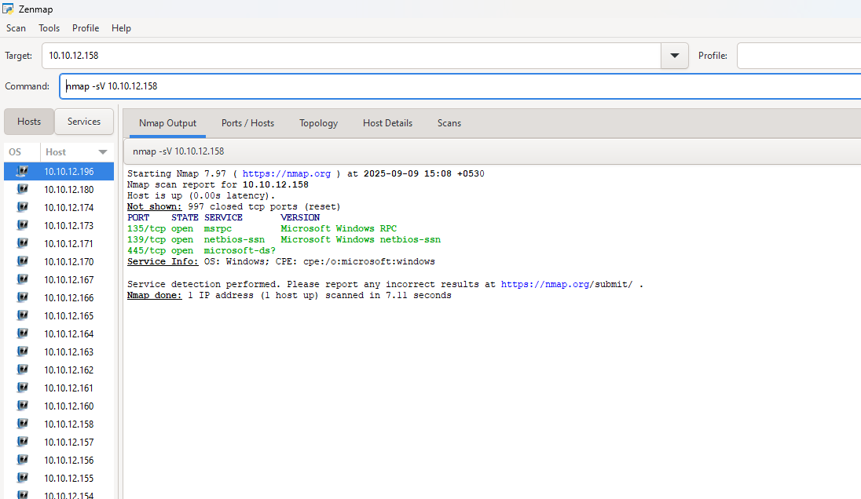

## 14. Find Operating System in a host using Nmap

**Command to Use:**

*nmap -O 10.10.12.163*

